Parameters that these menu points to are within the ()

ART Adverse Reaction Tracking Configuration ...

AUT Automatic Signature of Adverse Reaction Data (behoart autosign)
This menu automatically applies the signature of the user entering the allergy.
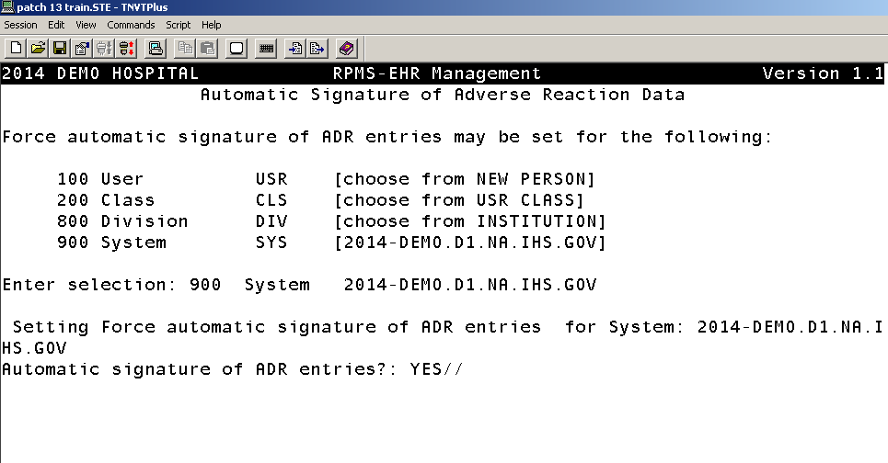

ENT Enable Adverse Reaction Data Entry (behoart data entry)
This menu allow entry of adverse reaction data in the cover sheet.

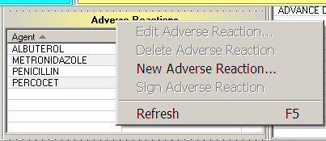
Enable Adverse Reaction Data Entry

Allow entry of adverse reaction data may be set for the following:

100 User USR [choose from NEW PERSON]
200 Class CLS [choose from USR CLASS]
800 Division DIV [choose from INSTITUTION]
900 System SYS [DEMO-HO.IHS.GOV]

Enter selection: 900 System DEMO-HO.IHS.GOV

- Setting Allow entry of adverse reaction data for System: DEMO-HO.IHS.GOV -
Allow entry of adverse reaction data?: YES// ??

If yes, the user is allow to enter and edit adverse reaction data.

VER Allow Adverse Reaction Verification
This menu allocates the GMRA-ALLERGY VERIFY key to whomever you add here.

DEMO HOSPITAL RPMS-EHR Management Version 1.1
Allow Adverse Reaction Verification

GMRA-ALLERGY VERIFY Key Management

Select a user for key assignment: ?? Answer with NEW PERSON NAME
Do you want the entire NEW PERSON List?

CCX Chief Complaint Configuration ...

DCC Disable chief complaint editing (bgo disable cpt editing)
This menu is where I can disable the ability for that user to enter or edit chief complaints. It is set either by user (100) or Class (200) and value is either yes or no.
PFX Prefix text for chief complaint pick lists (bgo cc prefix text)
This is the menu I would use to edit the prefix of chief complaint. In EHR v1.1 we have the ability to edit prefix plus a new category was added (disease). Once the prefix is set her, you then go into the GUI and add items to the different list. To edit these pick-lists, you have to right click in the chief complaint component in the GUI them select :manage pick-list” and edit your lists.
Prefix for chief complaint pick lists may be set for the following:

100 User USR [choose from NEW PERSON]
200 Class CLS [choose from USR CLASS]
500 Location LOC [choose from HOSPITAL LOCATION]
800 Division DIV [choose from INSTITUTION]
900 System SYS [DEMO-HO.IHS.GOV]
Enter selection: 900 System DEMO-HO.IHS.GOV
- Setting Prefix for chief complaint pick lists for System: DEMO-HO.IHS.GOV -
Select Pick list type: ?
Pick list type Value
-------------- -----
DISEASE Evaluation and Management of
Select one of the following:

1 SYMPTOM
2 DISEASE
3 REQUEST
Select Pick list type: 2 DISEASE
Pick list type: DISEASE// DISEASE
Prefix text: Evaluation and Management of Replace

CON Consult Tracking Configuration ...

CP Copy Prosthetics Services
DESCRIPTION: This option allows the copying of one of the nationally
exported Prosthetics services. These services have specific data in certain
fields that are critical to the interface between Consult/Request Tracking and
Prosthetics. ( Not used in IHS)

CS Consult Service Tracking
DESCRIPTION: This option provides actions which a service may use to track
consults and requests. Track by patient and you can see all consults for that patient. You can also get a detail view of that consult without going into the GUI.
Consult Service Tracking
Select Patient: DEMO,ALICE JANENE <AD> F 11-30-1952 602680084 CI 109629

Select Service/Specialty: ALL SERVICES// GROUPER ONLY
List From Starting Date: ALL DATES//

You get a neat list for all consults that patient had or pending for that time frame.
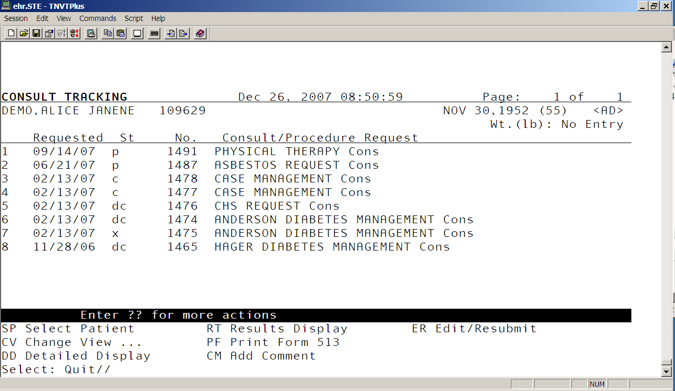

DS Duplicate Sub-Service
DESCRIPTION: This check if any Consult/Request Tracking REQUEST SERVICES (file #123.5) are Sub-Services of more than one Service. You can find any consult that may have been put into another consult as a sub-service to that consult. Mya be useful for troubleshooting problems.

Service MAYCOCK DIABETES MANAGEMENT is a sub service of:
ALL SERVICES
ANDERSON DIABETES MANAGEMENT

There is 1 service that is a sub-service for more than one service.

GU Group Update of Consult/Procedure Requests
Use this option to batch complete all old outstanding consults that no longer are valid. Only that person that has been setup in the special update individual during the consult setup (SPECIAL UPDATES INDIVIDUAL: USER,BSTUDENT// ) will be able to batch update that consult. Each consult service you make will need to have this field setup.
DESCRIPTION: This option will allow a search of the REQUEST/CONSULTATION (#123) file for requests to a particular service within a date range. The status of the entries meeting the selected criteria may be updated to COMPLETE or DISCONTINUED. A comment of up to 256 characters may be entered once and attached to each of the entries. A report of those records to be updated may be printed without performing the status updates. The option also allows printing of the records along with the status updates. The status of the corresponding order in CPRS will be updated to match that in file 123. Only the user entered in the SPECIAL UPDATES INDIVIDUAL field #123.5 of the REQUEST SERVICES (#123.5) file will be allowed to perform the updates for the chosen service. Only one person and not a team can be a special update individual.

Example how it works:
DEMO HOSPITAL RPMS-EHR Management Version 1.1
Group Update of Consult/Procedure Requests

Select Service/Specialty: ALL SERVICES// an
1 ANDERSON DIABETES MANAGEMENT
2 ANTICOAGULATION REQUEST
CHOOSE 1-2: 1 ANDERSON DIABETES MANAGEMENT
The first order in Consults has an entry date of JUN 25,2004
Update Status Start Date: JUN 25,2004// (JUN 25, 2004)
Update Status Stop Date: t (DEC 26, 2007) (DEC 26, 2007)
Response must not follow 11/26/2007.
Update Status Stop Date: 11/20/2007 (NOV 20, 2007)
1 = Pending
2 = Active
3 = Scheduled
4 = All
Enter any combination of numbers separated
by a comma or hyphen: (1-4): 1
If orders in the date range still have the selected status, this option
will change their status in consults, and update the order.
You may change the status to COMPLETE or DISCONTINUED.

Change their status to: complete

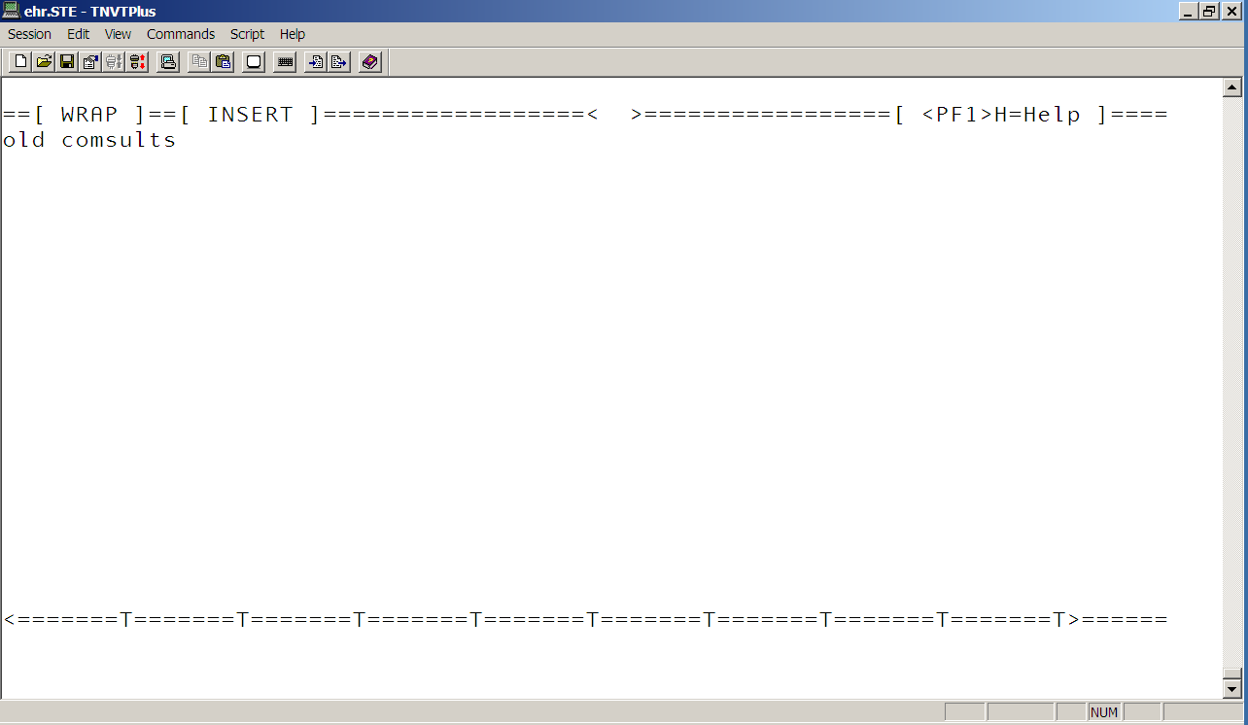

Records will be updated for:
------------------------------------------------------------------------------
Service: ANDERSON DIABETES MANAGEMENT
Beginning: Jun 25, 2004
Ending: Nov 20, 2007
Update: Pending Consults
To: COMPLETE
Update Comment:
old comsults
------------------------------------------------------------------------------

Is this correct? NO// y
Searching database for entries matching search criteria

Select one of the following:

1 Print report only
2 Print report & update records
3 Quit
Choose the method to handle the report: 2 Print report & update records

The device selected will print a list of entries from file 123 that will be
updated to COMPLETE.
If you choose to update records, the update of the consult entries will take
place upon completion of the report.
It is highly advised that a printer be selected!
Select device for report: e EHRIT Computer Room-HP LaserJet 5si
Do you want your output QUEUED? NO// y (YES)
WARNING - Records will automatically be updated since the
report is being tasked.
Do you wish to continue??? NO// y YES
Requested Start Time: NOW// (DEC 26, 2007@09:05:04)

Print out
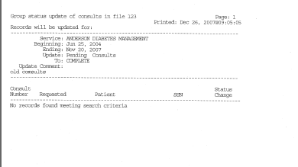

IFC IFC Management Menu ...
At this point this is not used in IHS
DESCRIPTION: This menu contains a collection of options used to implement
and manage the Inter-facility Consults interface.

LH List Consult Service Hierarchy
This option list all consults and how they appear on the consult hierarchy.
DEMO HOSPITAL RPMS-EHR Management Version 1.1
List Consult Service Hierarchy
DEVICE: HOME// VT
Consult Hierarchy list Dec 26, 2007@09:13:32 Page: 1
------------------------------------------------------------------------------
ALL SERVICES (Grouper Only)
ANDERSON DIABETES MANAGEMENT
MAYCOCK DIABETES MANAGEMENT
ANTICOAGULATION REQUEST
ASBESTOS REQUEST
BOEREMA DIABETES MANAGEMENT
CAC CONSULT
CASE MANAGEMENT
CHS REQUEST
<CONTACT LENS REQUEST> <Disabled>
CVD SERVICE REQUEST
DR COX CONSULT
DR GRIMES CONSULT
ECHO REQUEST
ENT REQUEST
<EYEGLASS REQUEST> <Disabled>
HAGER DIABETES MANAGEMENT
<HOME OXYGEN REQUEST> <Disabled>
JONES DIABETES MANAGEMENT
KNUTSON DIABETES MANAGEMENT
MAYCOCK DIABETES MANAGEMENT
MCGHEE DIABETES MANAGEMENT
NEUROLOGY REQUEST
NONFORMULARY PHARMACY REVIEW
NONFORMULARY REQUEST
NUTRITION REQUEST
OBESITY REQUEST
OBGYN REQUEST
PAIN MANAGEMENT REQUEST
PHYSICAL THERAPY
POMILLA DIABETES MANAGEMENT
<PROSTHETICS REQUEST> <Disabled>
QSTUDENT DIABETES MANAGEMENT
QUINN DIABETES CONSULT
Quinn Diabetes Management
SHAWNZ DIABETES MANAGEMENT
SHOEMAKER DIABETES MANAGEMENT
SPIROMETRY REQUEST
TOBACCO CESSATION REQUEST
UROLOGY REQUEST
WATERHOUSE DM MGT (Tracking Only)
WEBSTER DIABETES MANAGEMENT
WRIGHT DIABETES MANAGEMENT

Services not currently part of the Consults Hierarchy:
DURAN DIABETES MANAGEMENT
MAYCOCK DIABETIC MANAGEMENT
SHOEMAKER DIABETES CONSULT
CONTACT LENS REQUEST - lens request (Disabled)

NR Determine Notification Recipients for a Service
Description: Determine the notification recipients for a service. Useful for trouble shooting a consult service when recipients for that consult service are receiving or able to complete a consult.

How it works.
Select Service: andersON DIABETES MANAGEMENT
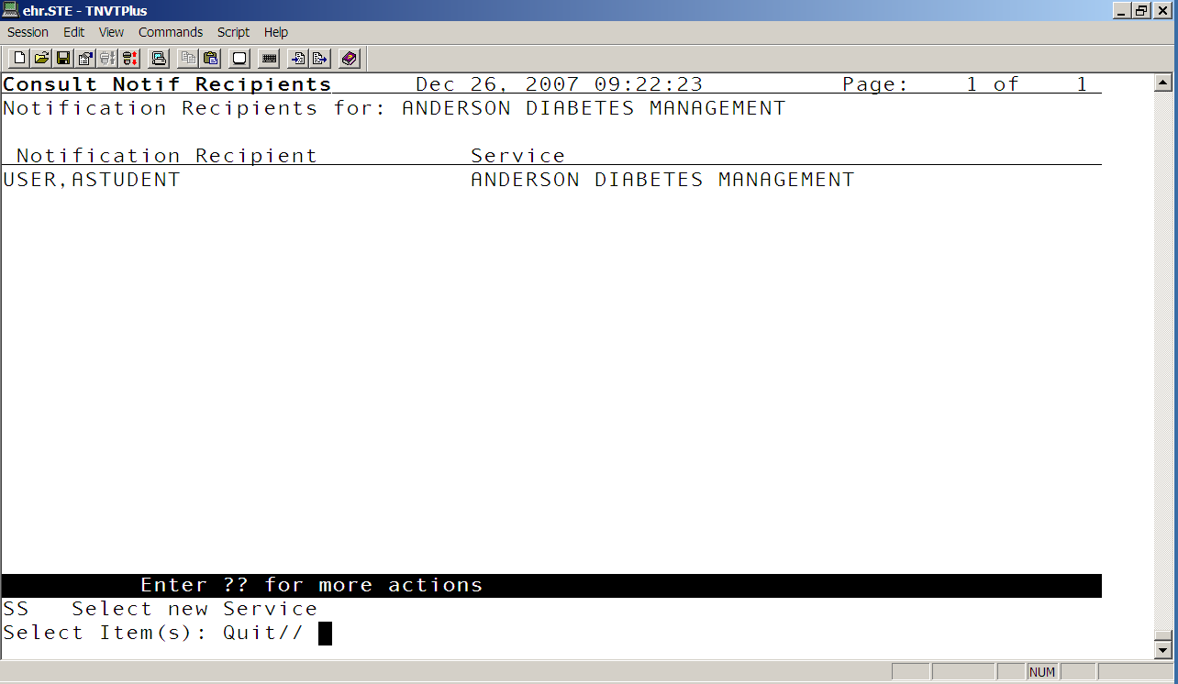

PR Setup Procedures
Same as the consult setup option. Early on I played with this option and created procedure consults. I was told that it was better to use the consult setup if I wanted to create procedure consults. The VA uses this.

RPT Consult Tracking Reports ...
Use this option to track consult status. You will find pending, complete, etc consults. This option is a menu that contains other options. You can play with this option to figure out how it works.

CC Service Consults Completed
CP Service Consults Completed or Pending Resolution
IFC IFC Requests
IP IFC Requests By Patient
IR IFC Requests by Remote Ordering Provider
NU Service Consults with Consults Numbers
PC Service Consults Pending Resolution
PI Print IFC Requests
PL Print Consults by Provider, Location, or Procedure
PR Print Service Consults by Status
SC Service Consults By Status
ST Completion Time Statistics
TS Print Completion Time Statistics Report

RX Pharmacy TPN Consults
I have no idea how this works. I looks like it is disable

SS Setup Consult Services
This option allows you to create new consult services. Once you create them, you will need to link these consult in the all service consult so that they will be available in the GUI. Caution: do not alter or change anything in the “all services” consult otherwise your consult system will not function properly. The only area you will edit will be the sub-service field. This field is where you will add your newly created consult.

SU Service User Management
DESCRIPTION: This option is used to identify individuals or teams which
should be notified when a Consult/Request is being sent to their receiving
service. It is also used to identify individuals who will not be notified when consults are being sent to the service, but DO have update/tracking capabilities for
the service. Individuals or teams may also be notified of a new consult based on the Patient's Location. When a Consult/Request is sent to a service, the Patient
Location will be checked. If the receiving service has broken down their service notification by Hospital location, the notification will be sent to the individual and/or a team defined in this option.

How it works.
DEMO HOSPITAL RPMS-EHR Management Version 1.1
Service User Management
Select Service/Specialty: ANDERSON DIABETES MANAGEMENT
SERVICE INDIVIDUAL TO NOTIFY: USER,ASTUDENT//
Select SERVICE TEAM TO NOTIFY:
Select NOTIFICATION BY PT LOCATION:

Select UPDATE USERS W/O NOTIFICATIONS: USER,BSTUDENT
//
Select UPDATE TEAMS W/O NOTIFICATIONS:
Select UPDATE USER CLASS W/O NOTIFS:
Select ADMINISTRATIVE UPDATE USER: MOSELY,ELVIRA//
ADMINISTRATIVE UPDATE USER: MOSELY,ELVIRA//
NOTIFICATION RECIPIENT:
Select ADMINISTRATIVE UPDATE USER:
Select ADMINISTRATIVE UPDATE TEAM:
SPECIAL UPDATES INDIVIDUAL: USER,BSTUDENT//

TD Test Default Reason for Request
DESCRIPTION: This option will allow the Clinical Coordinator or IRM to test
the default reason for request for a given service or procedure without
placing an order. This option prompts for the selection of a procedure or a service from the consult hierarchy and a patient name. The default reason will be presented based on the selected patient in a list manager format. This format allows searching, printing etc.

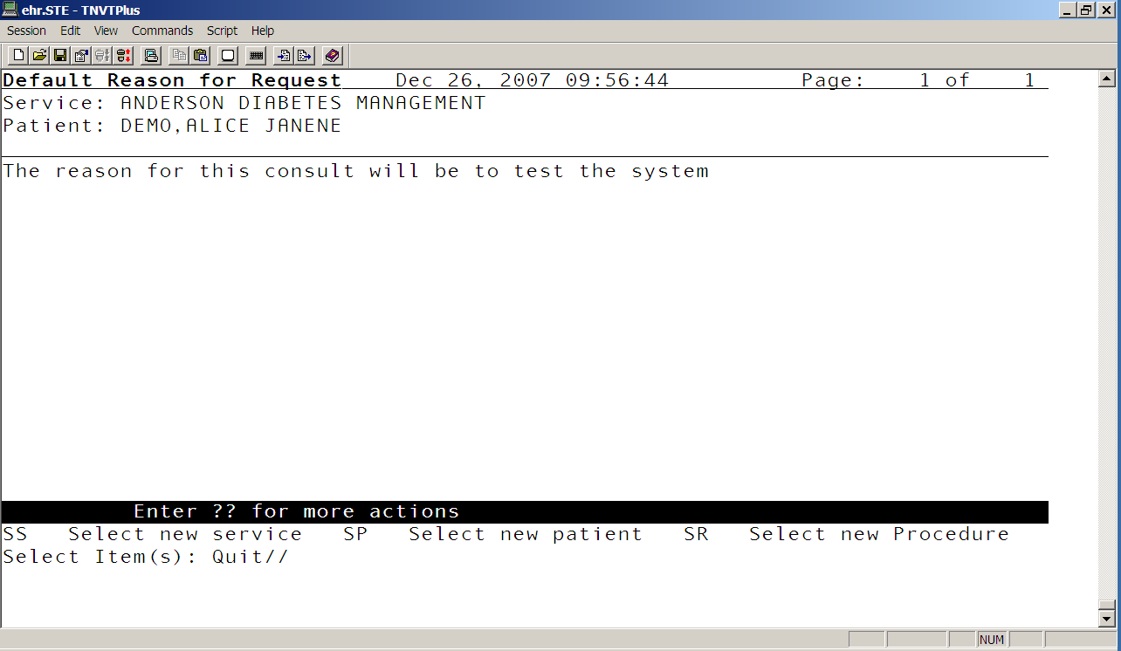

TP Print Test Page
DESCRIPTION: This option allows a user to select a printer for reviewing
print parameters. A report is generated which includes the current device
print parameters and a ruler to verify the length of the current print page. A
description of how to use the ruler is included in the report.

UA Determine User's Update Authority
This option will allow you to check a user's update authority for any given
service in the consults hierarchy. If the PROCESS PARENTS FOR UPDATES field is set to YES, all ancestors of the selected service will be checked.
The type of update authority and the service to which they are assigned will
be displayed.

How it works
Select Consult Service: andersON DIABETES MANAGEMENT
Choose user to check for update status: user,b USER,BSTUDENT

This user is an update user for: ANDERSON DIABETES MANAGEMENT
via the UPDATE USERS W/O NOTIFICATIONS field.

UN Determine If User Is a Notification Recipient
This option will list how a given user became a notification recipient
for a selected consult service. If the PROCESS PARENTS FOR NOTIFS field is
set to YES, all the parents of the service will also be processed to
determine if the user is a recipient via that service.

How it works:
In the “anderson diabetes” consult this is the user ser for notification recipient
SERVICE INDIVIDUAL TO NOTIFY: USER,ASTUDENT//

When I use this option here’s what I get:
Select Consult Service: ANDERSON DIABETES MANAGEMENT
Choose notification recipient: USER,ALLEN W

*this is not the person setup in the service to notify field so the system let me know that this person is not a notification recipient*

This user is not a notification recipient.

*Now I do this again but this time I put the user I have set in thet system*

Select Consult Service: anderSON DIABETES MANAGEMENT
Choose notification recipient: USER,ASTUDENT

This user is a notification recipients for ANDERSON DIABETES MANAGEMENT

EDU Patient Education Configuration ...

DPE Disable Patient Education Editing (bgo disable pat edu editing)
This option disables the editing of patient education. I can be set but user or by class.

Disable Patient Education Editing

Disable Patient Education Editing may be set for the following:

100 User USR [choose from NEW PERSON]
200 Class CLS [choose from USR CLASS]

------- Setting Disable Patient Education Editing for Class: PROVIDER -------
Value: ?
Enter either 'Y' or 'N'.

ENC Encounter Context Configuration ...

CRT Allow User to Create New Visits (behoencx create visit)
The option allows you to set who can create a new visit.

Allow User to Create New Visits

Allow user to create new visits. may be set for the following:

100 User USR [choose from NEW PERSON]
200 Class CLS [choose from USR CLASS]
300 Service SRV [choose from SERVICE/SECTION]
400 Location LOC [choose from HOSPITAL LOCATION]
500 Division DIV [choose from INSTITUTION]
900 System SYS [DEMO-HO.IHS.GOV]

--- Setting Allow user to create new visits. for System: DEMO-HO.IHS.GOV ---
Value: NO//
Enter either 'Y' or 'N'. Yes means that they can create new visit, no means they can not create a new visit.

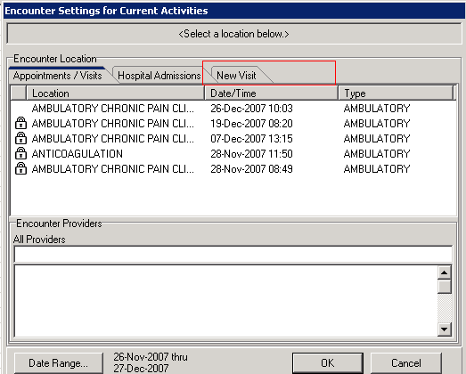

LCK Days After Which Visit is Locked (behoencx visit locked)
Here is where you enter the # of days before a visit is locked. Once the visit is lock, it can not be modified using the EHR. You can however edit the visit through PCC data entry menu.

Days After Which Visit is Locked

Number days visit can be modified. may be set for the following:

800 Division DIV [choose from INSTITUTION]
900 System SYS [DEMO-HO.IHS.GOV]

Enter selection: 900 System DEMO-HO.IHS.GOV

-- Setting Number days visit can be modified. for System: DEMO-HO.IHS.GOV --
Value: 1// ?

# of days (1-180) following creation after which a visit cannot be
modified.

OTH General Location for Outside Encounters (behoencx other locations)
You can set the general location for outside encounters. I could not find a description for why and when you would be using this option. As far as I know, IHS does not use it.

OVR Temporarily Override Visit Lock for User (behoencx visit lock override)
This parameter temporarily Override Visit Lock for User for a specific visit. The option does not automatically relock the visit once user is done editing the visit.

PRV Allow a User to be a Visit Provider (behoencx provider)
This option allows IRM or CAC to set who can be a visit provider. It can be set individually by user or by user class.

How it works:

DEMO HOSPITAL RPMS-EHR Management Version 1.1
Allow a User to be a Visit Provider

Can be a visit provider? may be set for the following:

10 User USR [choose from NEW PERSON]
100 Class CLS [choose from USR CLASS]

Enter selection: 100 Class USR CLASS
Select USR CLASS NAME: provider

----------- Setting Can be a visit provider? for Class: PROVIDER -----------
Can be a visit provider?: YES//

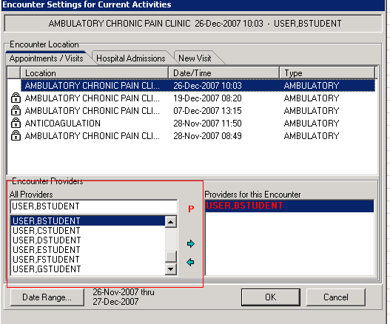

STP Visit Search Stop Date (behoencx search range stop)
This option allows you to set the date in which the system will stop searching for visit.

*below I have the system set to end search 2 day after today’s date*
Visit Search Stop Date
Visit Search Stop Date may be set for the following:

1 User USR [choose from NEW PERSON]
2 Service SRV [choose from SERVICE/SECTION]
3 Division DIV [choose from INSTITUTION]
5 System SYS [DEMO-HO.IHS.GOV]

Enter selection: 5 System DEMO-HO.IHS.GOV

-------- Setting Visit Search Stop Date for System: DEMO-HO.IHS.GOV --------
Visit Search Stop Date: T+2//

You are editing the appointment action component typically found on the cover sheet.
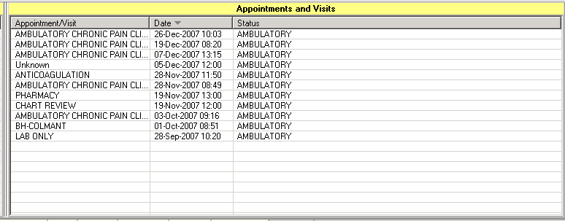

STR Visit Search Start Date (behoencx search range start)
This option allows you to set the date in which the system will start searching for visit.

*Mine is set to start 90 days back*
Visit Search Start Date

Visit Search Start Date may be set for the following:

1 User USR [choose from NEW PERSON]
2 Service SRV [choose from SERVICE/SECTION]
3 Division DIV [choose from INSTITUTION]
5 System SYS [DEMO-HO.IHS.GOV]

Enter selection: 5 System DEMO-HO.IHS.GOV

-------- Setting Visit Search Start Date for System: DEMO-HO.IHS.GOV --------
Visit Search Start Date: T-90//

TYP Selectable Visit Types (behoencx visit types)
This option is what regulates the EHR visit type.
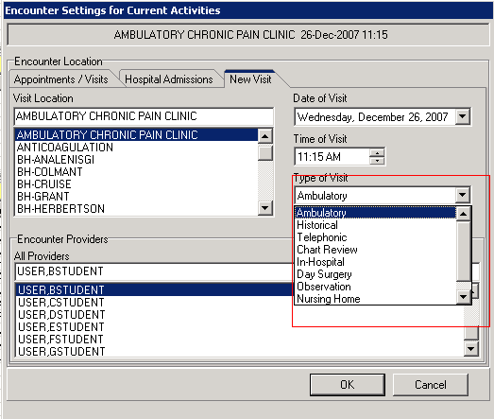

How it works:
*If for some reason your visit type in EHR is blank, edit this parameter. Make sure to put in the information below exactly how it is presented in this document.*

DEMO HOSPITAL RPMS-EHR Management Version 1.1
Selectable Visit Types

Selectable visit types may be set for the following:

5 Division DIV [choose from INSTITUTION]
10 System SYS [DEMO-HO.IHS.GOV]

Enter selection: 10 System DEMO-HO.IHS.GOV

-------- Setting Selectable visit types for System: DEMO-HO.IHS.GOV --------
Select Sequence: ?

Sequence Value
-------- -----
1 A~Ambulatory~Used for workload.
2 E~Historical~Used to document past events. Not used for workload.
3 T~Telephonic~Used to document informal patient encounters such as tel
4 C~Chart Review~Used to document chart reviews. Not used for workload
5 I~In-Hospital~Used to document ambulatory visits on hospitalized pati
6 S~Day Surgery~Used to document Day Surgery visits.
7 O~Observation~Observation
8 R~Nursing Home~Used to document nursing home visits.
9 N~Not Found~Used for service categories not otherwise specified.
EXM Exam Configuration ... (bgo disable exam editing)

DEE Disable Exam Editing
This option is used to disable exam component so that user can not enter or edit exams

DEMO HOSPITAL RPMS-EHR Management Version 1.1
Disable Exam Editing

Disable Exam Editing may be set for the following:

100 User USR [choose from NEW PERSON]
200 Class CLS [choose from USR CLASS]

Enter selection: 200 Class USR CLASS
Select USR CLASS NAME: provider

------------- Setting Disable Exam Editing for Class: PROVIDER -------------
Value: ?

Enter either 'Y' or 'N'.

FRM VueCentric Framework Configuration ...

- Site Parameter Edit (locked by CIAV site manager key)
This is the option available for CAC to edit the vuecentric framework.

DEMO HOSPITAL VUECENTRIC FRAMEWORK Version 1.1V2

Site Parameter Edit

VueCentric Site Parameters for System: DEMO-HO.IHS.GOV
------------------------------------------------------------------------------
Default object source path \\161.223.197.68\VUECENTRIC2\E
HR1.1\lib\
Default login template %ELVIRAS VERSION DEMO_TEMPLATE
Host polling interval 5
Maximum number of resource devices 4
Number of resource slots to allocate 4
Primary inactivity timeout 600
Secondary inactivity timeout 5400
Interval to display countdown timer 10
Disable CCOW support YES
------------------------------------------------------------------------------

------ Setting Default object source path for System: DEMO-HO.IHS.GOV ------
Object Source Path: \\161.223.197.68\VUECENTRIC2\EHR1.1\lib\

- Show Current VueCentric Users (locked by ciav site manager key)
This option shows all the EHR open sessions.

How it works:

DEMO HOSPITAL VUECENTRIC FRAMEWORK Version 1.1V2

Show Current VueCentric Users

DEVICE: HOME// VT Right Margin: 80//
#5952 Dec 26, 2007@11:03:54 PHX-AO-CACHE-12 USER,BSTUDENT

One session is active.

- Startup VueCentric Framework (locked by ciav site manager key)
Option allows CAC or IT to start the listener

- Shutdown VueCentric Framework (locked by ciav site manager key)
Option allows CAC or IT to stop the listener. Before you stop the listener, it will show all active sessions and you can set a time lag before EHR is turned off.

Shutdown VueCentric Framework

Initiate VueCentric Shutdown Sequence

#5952 Dec 26, 2007@11:03:54 PHX-AO-CACHE-12 USER,BSTUDENT

One session is active.

# of seconds till shutdown (30 minimum):

- Change Template Defaults (ciav default template)
This option allos CAC or IT to assign vuecentric templates to users without having to go through the VCManager program within the util folder on the EHR server.
DEMO HOSPITAL VUECENTRIC FRAMEWORK Version 1.1V2
Change Template Defaults
Default login template may be set for the following:
100 User USR [choose from NEW PERSON]
200 Class CLS [choose from USR CLASS]
300 Service SRV [choose from SERVICE/SECTION]
400 Location LOC [choose from HOSPITAL LOCATION]
500 Division DIV [choose from INSTITUTION]
900 System SYS [DEMO-HO.IHS.GOV]
Enter selection: 900 System DEMO-HO.IHS.GOV

-------- Setting Default login template for System: DEMO-HO.IHS.GOV --------
Default Template: %ELVIRAS VERSION DEMO_TEMPLATE//

6. Display Patches for a package
This option will print all patches installed for a Package. It
displays the Date Installed and who installed the patches. It optionally will
print the description of the patch. All information comes from the Package
file.

HFA Health Factor Configuration ...

DHE Disable Health Factor Editing (bgo disable HF editing)
This option allows CAC to disable health factor editing. It can be set by user or by class

DEMO HOSPITAL RPMS-EHR Management Version 1.1
Disable Health Factor Editing
Disable Health Factor Editing may be set for the following:
100 User USR [choose from NEW PERSON]
200 Class CLS [choose from USR CLASS]
Enter selection: 200 Class USR CLASS
Select USR CLASS NAME: provider

--------- Setting Disable Health Factor Editing for Class: PROVIDER ---------
Value: ?
Enter either 'Y' or 'N'.

IMM Immunization Configuration ...

DIE Disable Immunization Editing (bgo disable imm editing)
Use this option if you want to disable user from entering immunization using EHR. They can however still use RPMS immunization package to enter or edit immunization as long as they have the BIZ Immunization key.

DEMO HOSPITAL RPMS-EHR Management Version 1.1
Disable Immunization Editing
Disable Immunization Editing may be set for the following:
100 User USR [choose from NEW PERSON]
200 Class CLS [choose from USR CLASS]
Enter selection: 100 User NEW PERSON
Select NEW PERSON NAME: user,b USER,BSTUDENT

User no longer have access to add, edit or delete buttons.
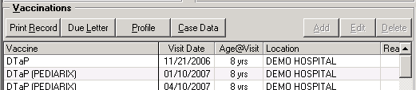

ICD Stop Immunizations from Adding ICD Codes (BGO imm stop adding ICD codes)
Use this option if you want to stop Immunizations from Adding ICD-9 Codes to your visit POV tab.

How it works:
DEMO HOSPITAL RPMS-EHR Management Version 1.1
Stop Immunizations from Adding ICD Codes
Stop Immunizations from Adding ICD Codes may be set for the following:
10 User USR [choose from NEW PERSON]
80 Division DIV [choose from INSTITUTION]
90 Package PKG [BGO COMPONENTS]
Enter selection: 90 Package BGO COMPONENTS
Parameters set for 'Package' may be replaced if BGO COMPONENTS
is installed in this account.
Setting Stop Immunizations from Adding ICD Codes for Package: BGO COMPONENTS
Value: ?
Enter either 'Y' or 'N'.

LAB Lab Configuration ...

CVR Days of Lab Results to Retrieve (Cover Sheet) (beholrcv date range)
This option set the number of days to display completed labs on the cover sheet. You set it for Outpatient and/or Inpatient wards. So you can have 30 days for retrieving labs for outpatient and maybe for inpatient you can set it to 15 days.

DEMO HOSPITAL RPMS-EHR Management Version 1.1
Days of Lab Results to Retrieve (Cover Sheet)
Duration for Lab Order Display may be set for the following:
100 User USR [choose from NEW PERSON]
200 Location LOC [choose from HOSPITAL LOCATION]
300 Service SRV [choose from SERVICE/SECTION]
400 Division DIV [choose from INSTITUTION]
900 System SYS [DEMO-HO.IHS.GOV]
Enter selection: 900 System DEMO-HO.IHS.GOV

--- Setting Duration for Lab Order Display for System: DEMO-HO.IHS.GOV ----
Select Inpatient/Outpatient: outp Outpatient

Inpatient/Outpatient: Outpatient// Outpatient
Number of Days to Display: 30//

MED Medication Management Configuration ...

ACT Days of Medication Activity (behorx days active)
In this parameter, CAC can configure # days of medication activity.

Days of Medication Activity
Days of Medication Activity may be set for the following:
100 User USR [choose from NEW PERSON]
800 Division DIV [choose from INSTITUTION]
900 System SYS [DEMO-HO.IHS.GOV]
Enter selection: 900 System DEMO-HO.IHS.GOV

------ Setting Days of Medication Activity for System: DEMO-HO.IHS.GOV ------
Days Active: 180//

*May system is set to bring 180 days worth of meds. However user can change this time frame. They simply need to click on the calendar icon on tool bar and change the number of days there. This in not permeant. Once that user signs off the system, it will go back to original timeframe. *

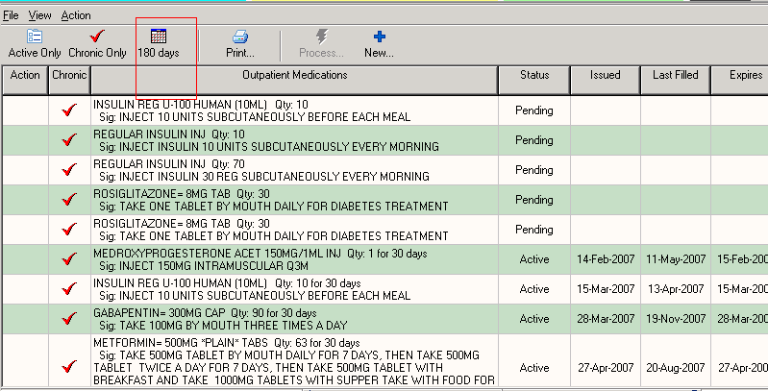

DEA Print DEA on all Prescriptions (BEHORX MAX DAYS SUPPLY)
Print DEA on all prescription. Enter the maximum days supply (90-365) allowed for a dispensed medication.

MAX Maximum Allowable Days Supply (BEHORX MAX DAYS SUPPLY)
Maximum allowable days supplies. Enter the maximum days supply (90-365) allowed for a dispensed medication.

MEC Medication Counseling Configuration ...
This option is a menu option for configuring the Pharmacy Ed button. See EHR v1.1 setup manual for complete detail on how to set up your pharm ed button.

DCMP Default Comprehension Value (BEHORXED COMPREHENSION DEFAULT)
Allows identification of a default value for the comprehension level control.
Enter a code from the list.

Select one of the following:

1 POORmec
2 FAIR
3 GOOD
4 GROUP-NO ASSESSMENT
5 REFUSED
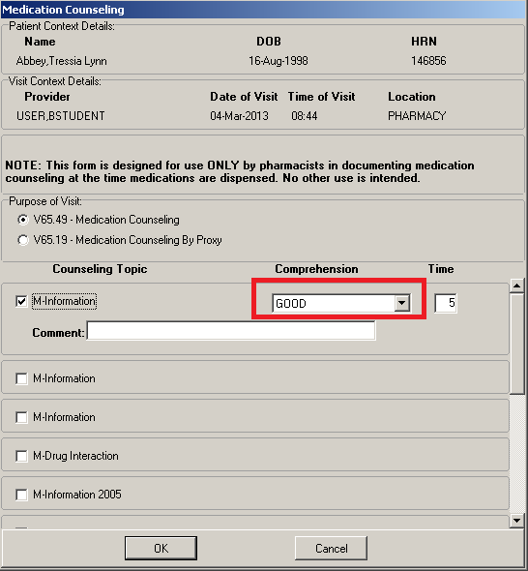
DCTM Default Counsel Time (BEHORXED COUNSEL TIME DEFAULT)
Enter the number of minutes to default for counseling

BEHORXED COUNSEL TIME DEFAULT may be set for the following:

80 Division DIV [choose from INSTITUTION]
90 System SYS [DEMO-HO.IHS.GOV]

Enter selection: 90 System DEMO-HO.IHS.GOV

----- Setting BEHORXED COUNSEL TIME DEFAULT for System: DEMO-HO.IHS.GOV -----
Counseling Time Default: 5// ?

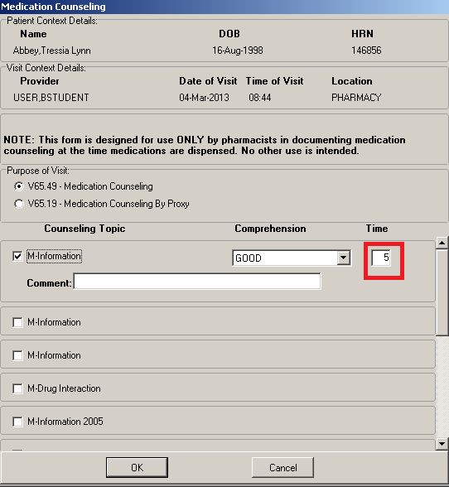

EDTX Edit Disclaimer Text (BEHORXED DISCLAIMER TEXT)
Holds disclaimer message text.

BEHORXED DISCLAIMER TEXT may be set for the following:

80 Division DIV [choose from INSTITUTION]
90 System SYS [DEMO-HO.IHS.GOV]

Enter selection: 90 System DEMO-HO.IHS.GOV

------- Setting BEHORXED DISCLAIMER TEXT for System: DEMO-HO.IHS.GOV -------
Edit Value: Y//

With the above value of “yes”
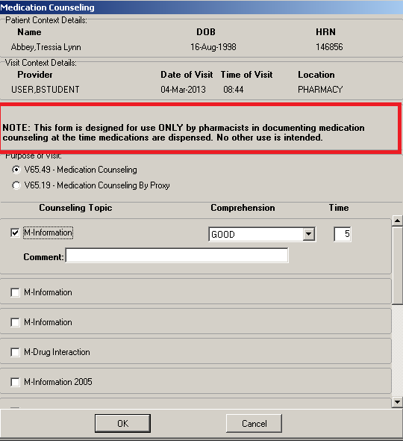

With no value:
------- Setting BEHORXED DISCLAIMER TEXT for System: DEMO-HO.IHS.GOV -------
Edit Value: Y// @ ...deleted

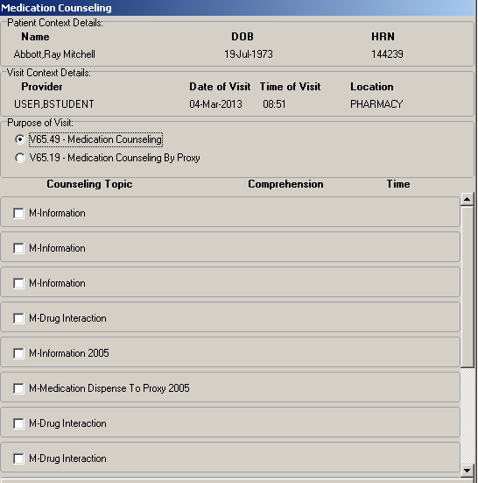

NOTE: If you delete the value, you actually delete the whole CAN phase. If you re-instate the value of “Y”, then you would need to re-enter the CAN statement.
BEHORXED DISCLAIMER TEXT may be set for the following:

80 Division DIV [choose from INSTITUTION]
90 System SYS [DEMO-HO.IHS.GOV]

Enter selection: 90 System DEMO-HO.IHS.GOV

------- Setting BEHORXED DISCLAIMER TEXT for System: DEMO-HO.IHS.GOV -------
Edit Value: Y// @ ...deleted

BEHORXED DISCLAIMER TEXT may be set for the following:

80 Division DIV [choose from INSTITUTION]
90 System SYS [DEMO-HO.IHS.GOV]

Enter selection: 90 System DEMO-HO.IHS.GOV

------- Setting BEHORXED DISCLAIMER TEXT for System: DEMO-HO.IHS.GOV -------
==[ WRAP ]==[ INSERT ]==================< y >================[ <PF1>H=Help ]====
NOTE: This form is designed for use ONLY by pharmacists in documenting
medication counseling at the time medications are dispensed. No other use
is intended.

<=======T=======T=======T=======T=======T=======T=======T

ELST Education Topics (BEHORXED EDUCATION TOPICS LIST)
Identifies which Education Topics may appear in the PharmED component

BEHORXED EDUCATION TOPICS LIST may be set for the following:

80 Division DIV [choose from INSTITUTION]
90 System SYS [DEMO-HO.IHS.GOV]

Enter selection: 90 System DEMO-HO.IHS.GOV

---- Setting BEHORXED EDUCATION TOPICS LIST for System: DEMO-HO.IHS.GOV ----
Select Sequence: ?

Sequence Value
-------- -----
1 M-INFORMATION
2 M-Information
4 M-Information
5 M-DRUG INTERACTION
6 M-INFORMATION 2005
8 M-MEDICATION DISPENSE TO PROXY 2005
10 M-Drug Interaction

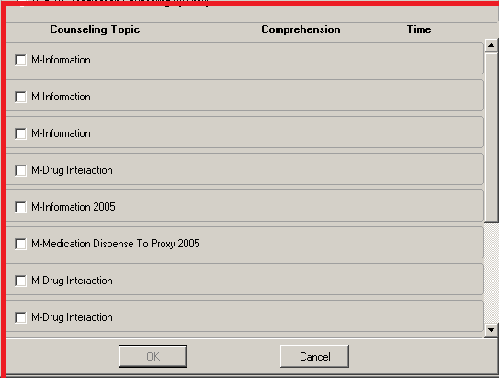

HL Hospital Location for Visit (BEHORXED DEF HOSP LOCATION)
Defines the clinic location it will default to.

BEHORXED DEF HOSP LOCATION may be set for the following:

80 Division DIV [choose from INSTITUTION]
90 System SYS [DEMO-HO.IHS.GOV]

Enter selection: 90 System DEMO-HO.IHS.GOV

------ Setting BEHORXED DEF HOSP LOCATION for System: DEMO-HO.IHS.GOV ------
Hospital Location for Visit: PHARMACY//
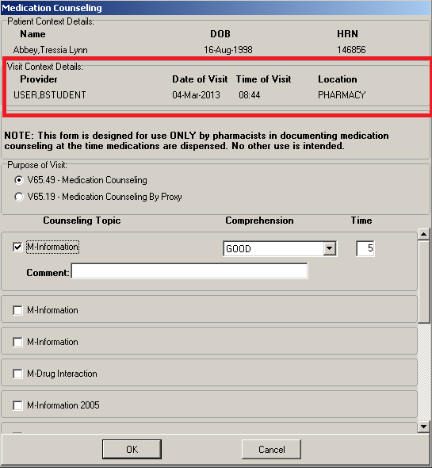

PLST POV List (BEHORXED POV LIST)
Identifies which POVs will appear for selection in the PharmED component.

BEHORXED POV LIST may be set for the following:

80 Division DIV [choose from INSTITUTION]
90 System SYS [DEMO-HO.IHS.GOV]

Enter selection: System DEMO-HO.IHS.GOV
----------- Setting BEHORXED POV LIST for System: DEMO-HO.IHS.GOV ---
Select Sequence: ?

Sequence Value
-------- -----
1 V65.49
2 V65.19
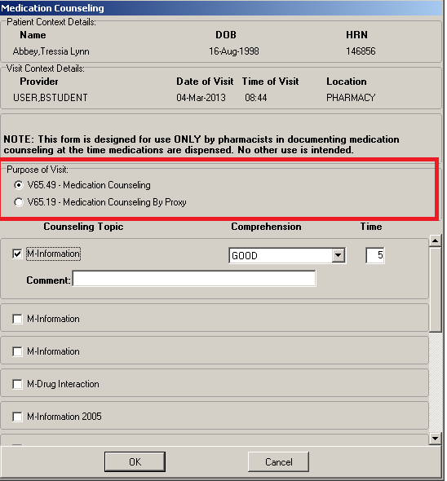

DPOV Default POV (BEHORXED DEFAULT POV)
Default the POV for pharmacy button.

BEHORXED DEFAULT POV may be set for the following:

80 Division DIV [choose from INSTITUTION]
90 System SYS [DEMO-HO.IHS.GOV]

Enter selection: 90 System DEMO-HO.IHS.GOV

--------- Setting BEHORXED DEFAULT POV for System: DEMO-HO.IHS.GOV ---------
Default POV code: V65.49// V65.49 OTHER SPECIFIED COUNSELING
...OK? Yes// (Yes)

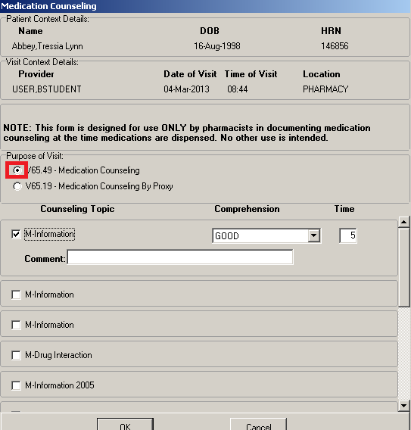

PNL POV Narrative Text (BEHORXED POV NARR TEXT)
Holds the Narrative Text value. The data sequence of this parameter must
match the order of the BEHORXED POV LIST parameter.

BEHORXED POV NARR TEXT may be set for the following:

80 Division DIV [choose from INSTITUTION]
90 System SYS [DEMO-HO.IHS.GOV]

Enter selection: 90 System DEMO-HO.IHS.GOV

-------- Setting BEHORXED POV NARR TEXT for System: DEMO-HO.IHS.GOV --------
Select Sequence: ?

Sequence Value
-------- -----
1 Medication counseling
2 Medication counseling by proxy

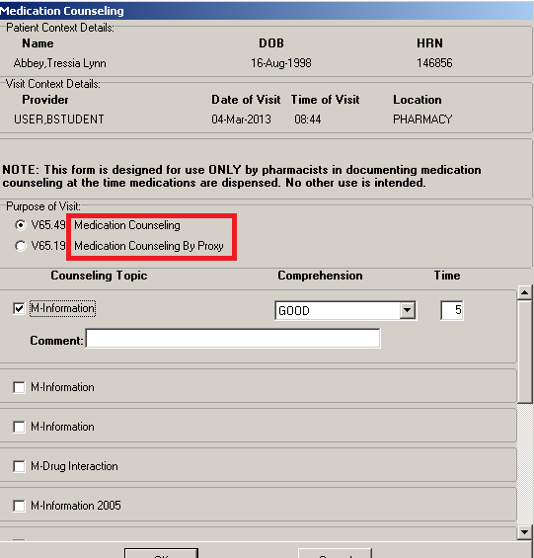

OMD Outside Med Dosage Form
(BEHORX OUTSIDE MED DOSAGE FORM)
This menu option sets the dosage form for the outside meds. **I do not have experience on this menu option.**

ORD Default Collation Order (behorx collation order)
This menu set the sorting method for your medication list.

How it works:
DEMO HOSPITAL RPMS-EHR Management Version 1.1
Default Collation Order
Medication List Collation Order may be set for the following:
100 User USR [choose from NEW PERSON]
800 Division DIV [choose from INSTITUTION]
900 System SYS [DEMO-HO.IHS.GOV]
Enter selection: 900 System DEMO-HO.IHS.GOV
---- Setting Medication List Collation Order for System: DEMO-HO.IHS.GOV ----
Collation Order: CSIMP// ??

Controls the default collation order for the medication list. May be one or
more of the following values:

C = Chronic med status
E = Expiration date
F = Last fill date
I = Issue date
M = Medication name
N = Rx #
P = Provider name
R = Refills remaining
S = Status

To reverse the collation order, use the lowercase equivalent.

PRT Medication Report Configuration ...
This Sub-Menu contains options related to Medication Routes in
both the MEDICATION ROUTES (#51.2) File and the STANDARD MEDICATION ROUTES
(#51.23) File.

DEF Set Default Printers for Medication Reports
(BEHORX PRINT DEFAULT)
Set Default Printers for Medication Reports

2014 DEMO HOSPITAL RPMS-EHR Management Version 1.1
Set Default Printers for Medication Reports

Default Printer for Med Print Action may be set for the following:

700 Location LOC [choose from HOSPITAL LOCATION]
800 Division DIV [choose from INSTITUTION]
900 System SYS [2014-DEMO.D1.NA.IHS.GOV]

Enter selection: 900 System 2014-DEMO.D1.NA.IHS.GOV

Setting Default Printer for Med Print Action for System: 2014-DEMO.D1.NA.IHS.G
OV
Select Report Type: EHR

There are currently no entries for Report Type.

Select one of the following:

0 Brief
1 Detailed
2 Prescription
3 Sample Label
4 Order
5 Receipt

Select Report Type: 2 Prescription
Are you adding Prescription as a new Report Type? Yes// YES

Report Type: Prescription// Prescription
Default Printer: EHR

LBL Enable Printing of Sample Labels
Enable Printing of Sample Labels

Enable Print Label Feature may be set for the following:

800 Division DIV [choose from INSTITUTION]
900 System SYS [2014-DEMO.D1.NA.IHS.GOV]

Enter selection: 900 System 2014-DEMO.D1.NA.IHS.GOV

-- Setting Enable Print Label Feature for System: 2014-DEMO.D1.NA.IHS.GOV --
Enable Print Label Feature: ?

Controls the availablility of the Print Rx print feature within EHR.

Enable Print Label Feature:YES

MAX Maximum # of Scripts per Page

Maximum # of Scripts per Page

Maximum # of scripts per page may be set for the following:

100 User USR [choose from NEW PERSON]
500 Class CLS [choose from USR CLASS]
800 Division DIV [choose from INSTITUTION]
900 System SYS [2014-DEMO.D1.NA.IHS.GOV]

Enter selection: 900 System 2014-DEMO.D1.NA.IHS.GOV

- Setting Maximum # of scripts per page for System: 2014-DEMO.D1.NA.IHS.GOV -
Value: 5//

REN Renewal Limit for Expired Meds (behorx rx expired max)
Use this menu to set the renewal limit for your medication.

Renewal Limit for Expired Meds
Renewal Limit (Days) for Expired Meds may be set for the following:
800 Division DIV [choose from INSTITUTION]
900 System SYS [DEMO-HO.IHS.GOV]
Enter selection: 900 System DEMO-HO.IHS.GOV

- Setting Renewal Limit (Days) for Expired Meds for System: DEMO-HO.IHS.GOV -
Renewal Limit (Days) for Expired Meds: ??
This is the maximum number of days following the expiration of a prescription
that it may still be renewed.

SPL Med Tab Splitter Size (BEHORX SPLITTER SIZE)
This parameter allows customization of the splitter positions on the Meds tab.

The input format is: 20;25;60;75

<inpatient top>;<inpatient bottom>;<outpatient top>;<outpatient bottom>

The numbers represent the size percentage of the two splitters.

Outpt Meds
=========Top Splitter=============
Outside Meds
=========Bottom Splitter==========
Inpatient Meds

Default values are:
Inpatient: 20;25
Outpatient: 60;75
Non-Hospital sites:
25;50;75;99 (the ‘99’ effectively hides the inpatient pane)
The percentages speaks to where the pane starts – so in the Non-hospital site example above is 25;50;75;99
Inpatients: the outside meds pane starts 25% down from top and inpatient meds in the middle. At a site with no hospital you will never see this.
Outpatients: the outside meds pane starts 75% down from top and the inpatient is not visible but you can see the splitter control to move into view. (good for a site that is NOT a hospital and would NEVER look at inpatient).
The option is located in both the XPAR General parameters menu and the RPMS-EHR Configuration Master Menu (by selecting -> MED -> SPL (Med Tab Splitter Size)).
In the following examples:
-- Setting BEHORX SPLITTER SIZE for System: DEMO-HO.BEM.IHS.GOV --
Value: 25;50;75;99//
• The first 2 numbers represents the display when you view a patient who is an INPATIENT
• The last 2 numbers represents a patient who is not admitted, so is outpatient
Below: Patient is INPATIENT Status
Figure 3-5: Patient is Inpatient Status in the EHR GUI
Below: Patient is OUTPATIENT Status (not Inpatient status)
Figure 3-6: Sample Patient is Outpatient status (not Inpatient status) in EHR GUI

NOT Notification Configuration ...

DET Determine Recipients
DESCRIPTION: Based on Notification, Patient and optional Order Number and
Default/ Regular Recipients, a list of recipients and potential recipients is
presented. This is a tool for IRM or Clinical Coordinators only. It will
enable the user to determine if and why a user receives a notification.

How it works:
Processing notification: ORDER REQUIRES ELEC SIGNATURE
for patient: DEMO,ALICE JANENE

Default recipient users and teams:
Recipients determined by Provider Recipient parameter:
Inpt primary provider:
Attending physician:
Teams/Personal Lists related to patient:
Patient list BLUE TEAM [TEAM PATIENT MANUAL]:
User MOSELY,ELVIRA is a potential recipient via team BLUE TEAM
MOSELY,ELVIRA: ON because
System default is Mandatory, no Division or Pt Location values.
[Surrogate USER,BSTUDENT will receive alert for user]
Ordering provider:

DIS Display Notifications a User Can Receive
This menu displays all the notifications a user can receive.

Notification List for USER,BSTUDENT Page: 1
Notification ON/OFF For This User and Why
-------------------------------- ---------------------------------------------
ABNORMAL IMAGING RESULTS ON System value is Mandatory
ABNORMAL LAB RESULT (INFO) OFF User value is Disabled
ABNORMAL LAB RESULTS (ACTION) ON User value is Enabled
ADMISSION ON User value is Enabled
CONSULT/PROC INTERPRETATION ON User value is Enabled
CONSULT/REQUEST CANCEL/HOLD ON User value is Enabled
CONSULT/REQUEST RESOLUTION ON User value is Enabled
CONSULT/REQUEST UPDATED ON User value is Enabled
CRITICAL LAB RESULT (INFO) OFF User value is Disabled
CRITICAL LAB RESULTS (ACTION) ON System value is Mandatory
DC ORDER OFF User value is Disabled
DECEASED PATIENT ON User value is Enabled
DISCHARGE OFF User value is Disabled
DNR EXPIRING OFF User value is Disabled
E&M CODE REQUIRED ON Division DEMO HOSPITAL value is Mandatory
ERROR MESSAGE OFF User value is Disabled
FLAG ORDER FOR CLARIFICATION ON User value is Enabled
FLAGGED OI EXPIRING - INPT OFF User value is Disabled
FLAGGED OI EXPIRING - OUTPT OFF User value is Disabled
FLAGGED OI ORDER - INPT OFF User value is Disabled
FLAGGED OI ORDER - OUTPT OFF User value is Disabled
FLAGGED OI RESULTS - INPT OFF User value is Disabled
FLAGGED OI RESULTS - OUTPT OFF User value is Disabled
FOOD/DRUG INTERACTION OFF User value is Disabled
FREE TEXT OFF User value is Disabled
IMAGING PATIENT EXAMINED ON User value is Enabled
IMAGING REQUEST CANCEL/HELD ON User value is Enabled
IMAGING REQUEST CHANGED OFF User value is Disabled
IMAGING RESULTS ON System value is Mandatory
IMAGING RESULTS AMENDED OFF User value is Disabled
LAB ORDER CANCELED OFF User value is Disabled
LAB RESULTS ON User value is Enabled
LAB THRESHOLD EXCEEDED OFF User value is Disabled
MEDICATIONS EXPIRING ON User value is Enabled
NEW ORDER ON User value is Enabled
NEW SERVICE CONSULT/REQUEST ON User value is Enabled
NPO DIET MORE THAN 72 HRS OFF User value is Disabled
ORDER CHECK OFF User value is Disabled
ORDER REQUIRES CHART SIGNATURE ON User value is Enabled
ORDER REQUIRES CO-SIGNATURE ON System value is Mandatory
ORDER REQUIRES ELEC SIGNATURE ON System value is Mandatory
ORDERER-FLAGGED RESULTS OFF User value is Disabled
POV REQUIRED ON Division DEMO HOSPITAL value is Mandatory
SERVICE ORDER REQ CHART SIGN ON System value is Mandatory
STAT IMAGING REQUEST OFF User value is Disabled
STAT ORDER OFF User value is Disabled
STAT RESULTS OFF User value is Disabled
TRANSFER FROM PSYCHIATRY OFF User value is Disabled
UNSCHEDULED VISIT ON User value is Enabled
UNVERIFIED MEDICATION ORDER ON System value is Mandatory
UNVERIFIED ORDER ON System value is Mandatory
URGENT IMAGING REQUEST OFF User value is Disabled
- End of Report -

ERA Erase Notifications
DESCRIPTION: Erase all notifications for a User, erase all notifications for
a Patient, or erase a specific Notification. I commonly use # 4 below to erase a specific notification. Example a nurse how holds the ORELSE key is getting a notification to sign a lab result. Only holders of the ORES key can sign off lab results notification. I usually have the nurse forward that notification to the provider then I erase that notification using option 4.

Erase Notifications

1. Erase all notifications for a User

2. Erase all notifications for a Patient

3. Erase all instances of a notification (regardless of Patient or User)

4. Erase specific notifications for a User

5. Edit Erase All Notifications parameter for a User

FLG Flag Orderable Items to Send Notifications
DESCRIPTION: Two sub-options to flag specific orderable items to send
notifications when they are ordered or resulted. This menu is mainly used for inpatient wards. There is a lot of configuration that goes on in order to make this notification work properly.

Sub-menus:
Flag ORDERABLE ITEMS to send Notifications

1. Flag INPATIENT orders/results/expiring orders.
2. Flag OUTPATIENT orders/results/expiring orders.
3. Flag Lab tests for Threshold Exceeded alerts.

Select "1" to flag INPT orders/results, "2" to flag OUTPT orders/results, "3" to
set Lab Thresholds:

FWD Forward Notifications ...
You need to have the service section file configure right for the supervisor one to work correctly. The other ones are easy to set up. Also it does not do all the notifications but just those notifications you set.
DESCRIPTION: This menu option is used to access options which set up
parameters for forwarding notifications/alerts.

DEMO HOSPITAL RPMS-EHR Management Version 1.1
Forward Unprocessed Notification to Backup

BCK Forward Unprocessed Notification to Backup
SUP Forward Unprocessed Notification to Supervisor
SUR Forward Unprocessed Notification to Surrogates

PAR Notification Parameters ...
This is a menu option where you set the whole notification system.

DEMO HOSPITAL RPMS-EHR Management Version 1.1
Set Show All Notifications

ALL Set Show All Notifications
BUL Send Flagged Orders Bulletin
DEL Set Deletion Parameters
EMC Providers that Require an E&M Code
PRG Set Purging Interval
PRI Priority Threshold for Popup Alerts
PRV Set Provider Recipients
RCD Set Default Recipient Devices
RCP Set Default Recipients
SRT Notification Sort Column
Break down of this menu:
ALL Set Show All Notifications (behoxq show all)
If set to YES, the default setting for displaying notifications in the
graphical interface is "all patient". If set to NO, the default setting
is "selected patient only".

DEMO HOSPITAL RPMS-EHR Management Version 1.1
Set Show All Notifications

Show All Notifications may be set for the following:
10 User USR [choose from NEW PERSON]
90 Division DIV [choose from INSTITUTION]
100 System SYS [DEMO-HO.IHS.GOV]
Enter selection: 100 System DEMO-HO.IHS.GOV
-------- Setting Show All Notifications for System: DEMO-HO.IHS.GOV --------
Value: YES// ?
Enter either 'Y' or 'N'.

BUL Send Flagged Orders Bulletin (orb flagged orders bullentin)
'Yes' indicates a MailMan bulletin will be sent to the order's Current
Provider (usually the Ordering Provider) when the order is flagged for
clarification. This parameter has no effect on the Flagged Orders
notification which is also triggered when an order is flagged for
clarification.
Send Flagged Orders Bulletin
Send Flagged Orders Bulletin may be set for the following:

1 User USR [choose from NEW PERSON]
2 Service SRV [choose from SERVICE/SECTION]
3 Division DIV [choose from INSTITUTION]
4 System SYS [DEMO-HO.IHS.GOV]
5 Package PKG [ORDER ENTRY/RESULTS REPORTING]
Enter selection: 4 System DEMO-HO.IHS.GOV
----- Setting Send Flagged Orders Bulletin for System: DEMO-HO.IHS.GOV -----
Value: yes// ??

DEL Set Deletion Parameters (orb delete mechanism)
Set of codes used to determine how a notification will be deleted at a
site. Codes include: I (Individual Recipient): delete the notification
for an individual recipient when a) that individual completes the
follow-up action on notifications with associated follow-up action, b)
that individual reviews notifications without follow-up actions. A (All
Recipients): delete the notification for all recipients when a) any
recipient completes the follow-up action on notifications with follow-up
actions, b) any recipient reviews notifications without follow-up
actions.

DEMO HOSPITAL RPMS-EHR Management Version 1.1
Set Deletion Parameters

Delete Mechanism may be set for the following:

1 Division DIV [choose from INSTITUTION]
2 System SYS [DEMO-HO.IHS.GOV]
3 Package PKG [ORDER ENTRY/RESULTS REPORTING]

Enter selection: 3 Package ORDER ENTRY/RESULTS REPORTING
Parameters set for 'Package' may be replaced if ORDER ENTRY/RESULTS REPORTING is installed in this account.

---- Setting Delete Mechanism for Package: ORDER ENTRY/RESULTS REPORTING ----
Select Notification: ORDER CHECK
CHECK ORDER CHECK
Value: Individual Recipient// ?

Enter 'I' if deleted on individual review/action; 'A' for all recipients.
Select one of the following:
I Individual Recipient
A All Recipients

EMC Providers that Require an E&M Code (behoxqpc requires E&M codes)
This menu set whether or not a primary provider requires an E&M code for billing purposes. Turns off the notification for a missing E&M code. It get set by class or by user.

DEMO HOSPITAL RPMS-EHR Management Version 1.1
Providers that Require an E&M Code

Provider requires E&M code? may be set for the following:

10 User USR [choose from NEW PERSON]
50 Class CLS [choose from USR CLASS]

Enter selection: 50 Class USR CLASS
Select USR CLASS NAME: Medical Technologist

-- Setting Provider requires E&M code? for Class: Medical Technologist -
Value: NO// ?

HNT Set Show Hint Dialog (BEHOXQ SHOW HINT)
If set to YES, the default setting for displaying the hint dialog for each notification is enabled. If set to NO, no hint dialog appears.

PRG Set Purging Interval (orb archive period)
This option sets the number of days to archive a notification for a site. If notindicated, the default period of 30 days is used. The maximum number ofdays is 100,000 or about 220 years. This value is passed to the Kernel
Alert Utility where the actual archiving and deletion ofalerts/notifications occurs. Does not set it for the whole system, but you need to select the notifications you want to set.

DEMO HOSPITAL RPMS-EHR Management Version 1.1
Set Purging Interval
Grace Period Before Deletion may be set for the following:

1 Division DIV [choose from INSTITUTION]
2 System SYS [DEMO-HO.IHS.GOV]
3 Package PKG [ORDER ENTRY/RESULTS REPORTING]

Enter selection: 3 Package ORDER ENTRY/RESULTS REPORTING
Parameters set for 'Package' may be replaced if ORDER ENTRY/RESULTS REPORTING
is installed in this account.
Setting Grace Period Before Deletion for Package: ORDER ENTRY/RESULTS REPORTING
Select Notification:

PRI Priority Threshold for Popup Alerts (behoxq alert threshold)
This is the alert priority threshold at or above which a popup alert will be displayed when an alert of that or greater priority is received. You can set it for none, high, medium and low notifications.

DEMO HOSPITAL RPMS-EHR Management Version 1.1
Priority Threshold for Popup Alerts
Priority threshold for Popup Alert may be set for the following:
10 User USR [choose from NEW PERSON]
90 Division DIV [choose from INSTITUTION]
100 System SYS [DEMO-HO.IHS.GOV]
Enter selection: 100 System DEMO-HO.IHS.GOV
-- Setting Priority threshold for Popup Alert for System: DEMO-HO.IHS.GOV --
Priority: High// ??
Possiblevalues are:
0 None
1 High
2 Medium
3 Low

Priority: High//

PRV Set Provider Recipients (orb provider recipients)
Set of codes indicating default provider recipients of a notification by
their title or relationship to the patient. Notifications can be set up
with any or all of the following codes:

P (Primary Provider): deliver notification to the patient's Primary
Provider.
A (Attending Physician): deliver notification to the patient's Attending
Physician.
T (Patient Care Team): deliver notification to the patient's primary
care Team.
O (Ordering Provider): deliver notification to the provider
who placed the order which trigger the notification.
M (PCMM Team): deliver notification to users/providers linked to the
patient via PCMM Team Position assignments.
E (Entering User): deliver notification to the user/provider who entered
the order's most recent activity.
R (PCMM Primary Care Practitioner): deliver notification to the
patient's PCMM Primary Care Practitioner.
S (PCMM Associate Provider): deliver notification to the patient's PCMM
Associate Provider.
D (IHS Primary Care Provider): deliver notification to the patient's
Primary Care Provider.
I (IHS Primary Team): deliver notification to the patient's Primary
Team.
G (IHS Designated Providers): deliver notification to all of the patient's
Designated Providers.

The providers, physicians and teams must be set up properly and accurately for the correct individuals to receive the notification.

How it works:
Set Provider Recipients

Provider Recipients may be set for the following:

1 Division DIV [choose from INSTITUTION]
2 System SYS [DEMO-HO.IHS.GOV]
3 Package PKG [ORDER ENTRY/RESULTS REPORTING]

Enter selection: Package ORDER ENTRY/RESULTS REPORTING

Parameters set for 'Package' may be replaced if ORDER ENTRY/RESULTS REPORTING
is installed in this account.

-- Setting Provider Recipients for Package: ORDER ENTRY/RESULTS REPORTING --
Select Notification: ORDER REQUIRES ELEC SIGNATURE

Notification: ORDER REQUIRES ELEC SIGNATURE// ORDER REQUIRES ELEC SIGNATURE
ORDER REQUIRES ELEC SIGNATURE
Value: OAPT//

RCD Set Default Recipient Devices (orb default recipients devices)
DESCRIPTION: Enter 'Yes' if the device should always receive this
notification. Devices will receive the notification on a regular basis -
despite setting in the option Enable/Disable Notifications. These devices
will always receive the notification, regardless of patient.

Set Default Recipient Devices

Notification Regular Recipient Devices may be set for the following:

1 Division DIV [choose from INSTITUTION]
2 System SYS [DEMO-HO.IHS.GOV]

Enter selection: System DEMO-HO.IHS.GOV

Setting Notification Regular Recipient Devices for System: DEMO-HO.IHS.GOV
Select Notification: ORDER CHECK
Are you adding ORDER CHECK as a new Notification? Yes// YES

Notification: ORDER CHECK// ORDER CHECK ORDER CHECK
Value: ←Put RPMS printer here.

RCP Set Default Recipients (orb default recipients)
DESCRIPTION: Enter 'Yes' if the recipient should always receive this
notification. Recipients (users,teams) will receive the notification on a
regular basis - despite settings in the option Enable/Disable Notifications.
These recipients will always receive the notification, regardless of patient.

DEMO HOSPITAL RPMS-EHR Management Version 1.1
Set Default Recipients

Notification Regular Recipients may be set for the following:

1 User USR [choose from NEW PERSON]
2 Team (OE/RR) OTL [choose from OE/RR LIST]

Enter selection: 2 Team (OE/RR) OE/RR LIST
Select OE/RR LIST NAME: blue TEAM

---- Setting Notification Regular Recipients for Team (OE/RR): BLUE TEAM ----
Select Notification: order
1 ORDER CHECK
2 ORDER REQUIRES CHART SIGNATURE
3 ORDER REQUIRES CO-SIGNATURE
4 ORDER REQUIRES ELEC SIGNATURE
5 ORDERER-FLAGGED RESULTS
CHOOSE 1-5: 4 ORDER REQUIRES ELEC SIGNATURE
Are you adding ORDER REQUIRES ELEC SIGNATURE as a new Notification? Yes// YES
Notification: ORDER REQUIRES ELEC SIGNATURE// ORDER REQUIRES ELEC SIGNATURE
ORDER REQUIRES ELEC SIGNATURE
Value: ? Enter 'yes' if this person or team should always receive the
notification.

SRT Notification Sort Column (behoxq sort by)
Set sorting method for notifications.
DEMO HOSPITAL RPMS-EHR Management Version 1.1
Notification Sort Column
Notification Sort Method may be set for the following:
100 User USR [choose from NEW PERSON]
200 Division DIV [choose from INSTITUTION]
400 System SYS [DEMO-HO.IHS.GOV]
Enter selection: 400 System DEMO-HO.IHS.GOV
------- Setting Notification Sort Method for System: DEMO-HO.IHS.GOV -------
Value: Type// ?
Sort method for notification display as P:Patient, T:Type, U:Urgency.
Select one of the following:
P Patient
T Type
U Urgency

PRC Enable/Disable Notifications (orb processing flag)
DESCRIPTION: Set of codes indicating processing flag for the entity and
notification.
E (Enabled): Notification enabled for entity unless entity of
higher precedence has notification disabled, e.g. Enabled
at System level and Disabled at User level - User will
not receive notification.
D (Disabled): Notification disabled for entity unless entity of
higher precedence has notification enabled, e.g. Dis-
abled at System level and Enabled at User level - User
will receive notification. [Note: If the option Set
Default Recipients for Notifications (parameter ORB3
REGULAR RECIPIENTS) is set to 'True' for a Team or
User, that Team or User will always receive the notifi-
cation, regardless of the Enabled/Disabled settings.]
[Second Note: During alpha, Class and Service will not
affect processing.]

*you will need to go through all your notifications and set them enable, disable or mandatory*

DEMO HOSPITAL RPMS-EHR Management Version 1.1
Enable/Disable Notifications
Processing Flag may be set for the following:

1 User USR [choose from NEW PERSON]
2 Team (OE/RR) OTL [choose from OE/RR LIST]
3 Service SRV [choose from SERVICE/SECTION]
4 Location LOC [choose from HOSPITAL LOCATION]
5 Division DIV [choose from INSTITUTION]
6 System SYS [DEMO-HO.IHS.GOV]
7 Package PKG [ORDER ENTRY/RESULTS REPORTING]

Enter selection: 7 Package ORDER ENTRY/RESULTS REPORTING
Parameters set for 'Package' may be replaced if ORDER ENTRY/RESULTS REPORTING
is installed in this account.
---- Setting Processing Flag for Package: ORDER ENTRY/RESULTS REPORTING ----
Select Notification: ORDER REQUIRES ELEC SIGNATURE
Notification: ORDER REQUIRES ELEC SIGNATURE// ORDER REQUIRES ELEC SIGNATURE
ORDER REQUIRES ELEC SIGNATURE
Value: Mandatory//
Select one of the following:

M Mandatory
E Enabled
D Disabled

REC Display Patient Alerts and Alert Recipients
DESCRIPTION: This option prompts for a patient then displays all Kernel
Alerts for that patient. You are then prompted to select one or more alerts.
Recipients of those alerts are then displayed or printed along with relevant
data regarding how they processed the alert. This option uses the Alert
Tracking file [^XTV(8992.1]. If an alert has an associated order number, it
is displayed in brackets.

DEMO HOSPITAL RPMS-EHR Management Version 1.1
Display Patient Alerts and Alert Recipients
PATIENT (req'd):
DEMO,ALICE JANENE <AD> F 11-30-1952 602680084 CI 109629
Start Date/Time (req'd): T-30// (NOV 26, 2007)
End Date/Time (req'd): NOW// (DEC 26, 2007@14:32)
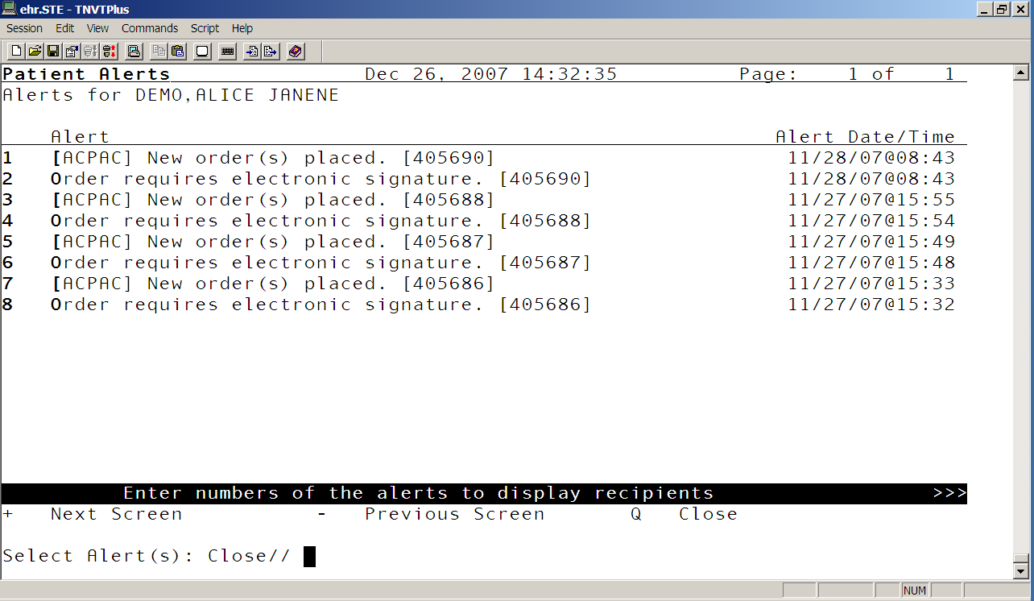

Select one of the notifications above tp get details on what happen to that notification.
RECIPIENTS OF ALERTS FOR PATIENT: DEMO,ALICE Page: 1

RECIPIENTS OF ALERT: [ACPAC] New order(s) placed. [405690]

USER,BSTUDENT
1st displayed to recipient: Nov 28, 2007@08:47:43
1st selected by recipient:
Processed by recipient: Dec 20, 2007@08:02:27
Deleted: Dec 20, 2007@08:02:27
Auto deleted:
Forwarded by:
Forwarded to recipient:
Non-process deletion by:

SYS Enable/Disable Notification System (orb system enable/disable)
This option turns on the whole notification system.

DEMO HOSPITAL RPMS-EHR Management Version 1.1
Enable/Disable Notification System

Enable or disable notifications. may be set for the following:

1 Division DIV [choose from INSTITUTION]
2 System SYS [DEMO-HO.IHS.GOV]
3 Package PKG [ORDER ENTRY/RESULTS REPORTING]

Enter selection: 2 System DEMO-HO.IHS.GOV
--- Setting Enable or disable notifications. for System: DEMO-HO.IHS.GOV ---
Value: Enable// ?
Enter 'Enable/E' for notifications, 'Disable/D' to stop notifications.
Select one of the following:
E Enable
D Disable

UNV Set Delays for Unverified Orders
This menu option provides access to options which set up
parameters for delaying unverified orders alert triggers.

Submenus:

DEMO HOSPITAL RPMS-EHR Management Version 1.1
Set Delays for Unverified Orders

MED Set Delay for Unverified Medication Orders (
ORD Set Delay for Unverified Orders

*you set the number of hours to delay triggering an unverified order
notification/alert. This parameter is used for all types of orders*

URG Set Urgency for Notifications (orb urgency)
DESCRIPTION: Set of codes indicating the urgency for a notification for a
site. The urgency is mainly used for sorting in displays. The codes include:

1 (High): notification is Highly urgent
2 (Moderate): notification is Moderately urgent
3 (Low): notification is of Low urgency

ORD Order Entry Configuration ...

DOC Delayed Orders Configuration ...
This menu is for configuring inpatient delay orders

KEY Key Management ...
This option is where you allocate and de-allocate order keys (ORES, ORELSE, OREMAS)

ALL Allocate OE/RR Security Keys
This menu option is used to allocate order keys.

KEY: ORES
This key is given to users that are authorized to write orders in
the chart. Users with this key can verify with their electronic
signature patient orders.
This key is typically given to licensed Physicians.
Orders entered by users with this key can be released to the ancillary
service for immediate action.
DO NOT give users both the ORES key and the ORELSE key.

KEY: ORELSE
This key is given to users that are authorized to release doctors
orders to an ancillary service for action.
This key is typically given to Nurses.
Users with this key are allowed to put verbal orders in the system
and release them to the service for action.
DO NOT give users both the ORES key and the ORELSE key.

KEY: OREMAS
This is the key given to MAS Ward Clerks. It allows the user to
specify patient orders as 'signed on chart' when entered, which
releases the orders to the service for action. Users with this
key are not allowed to put verbal orders in the system.

CHK Check for Multiple Keys
This menu check for anyone that has multiple order keys. User can only have one order key otherwise they will not able to order anything.

This is how it works:
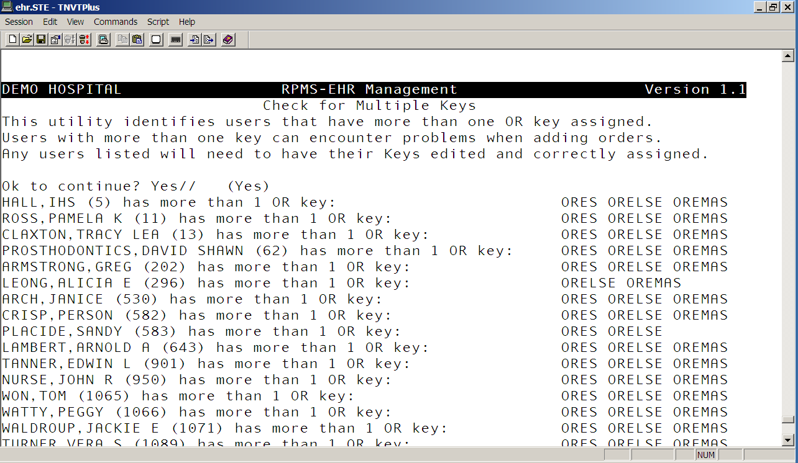

MNU Order Menu Management ...
DESCRIPTION: This option lets you create or change the Add Orders menus for
your site.
ACT Create/Modify Actions
DIS Enable/Disable Order Dialogs
GEN Create/Modify Generic Orders
LST List Primary Order Menus
MNU Create/Modify Order Menus
OIC Create/Modify Orderable Items
PAR Menu Parameters ...
PMT Create/Modify Prompts
PRI Assign Primary Order Menu
PRT Convert Protocols
QOC Create/Modify Quick Orders
QOR Create/Modify QO Restrictions
SET Create/Modify Order Sets
SRC Search/Replace Components
SRO Search/Replace Orderables

ACT Create/Modify Actions
DESCRIPTION: This option lets you create or change actions that may be placed on Add Orders menus. This menu creates actions used for generic orders. It involves creation of mump codes.

How it works:
Create/Modify Actions
Select ACTION NAME: LRX NEW COLLECTION METHOD
NAME: LRX NEW COLLECTION METHOD Replace
DISPLAY TEXT: New Collection Method Replace
ENTRY ACTION: N ORD,ORP S ORD=$$PTR^ORCD("LR OTHER LAB TESTS"),ORP=$$PTR^ORCD("O
R GTX COLLECTION TYPE") K ^TMP("ORECALL",$J,ORD,ORP)
Replace
EXIT ACTION:
DESCRIPTION:
No existing text
Edit? NO//

DIS Enable/Disable Order Dialogs
DESCRIPTION: This option lets you disable order dialogs so that execution will be prevented if selected; dialogs may also be re-enabled in this option.

How it works:

DEMO HOSPITAL RPMS-EHR Management Version 1.1
Enable/Disable Order Dialogs
Select ORDER DIALOG: LRZ 6-21 YR
ANOTHER ONE:

Enter a message to disable the dialog(s), or @ to enable again.
MESSAGE: OUT OF SERVICE

Are you ready? NO// YES.
done.

GEN Create/Modify Generic Orders
DESCRIPTION: This option lets you create or change generic text orders that may be placed on Add Orders menus; limited access to some clinical service ordering dialogs is also available through this option.

How it works:

DEMO HOSPITAL RPMS-EHR Management Version 1.1
Create/Modify Generic Orders
Select ORDER DIALOG NAME: LR OTHER LAB TESTS
DISPLAY TEXT: Laboratory//
SIGNATURE REQUIRED: ORES//
VERIFY ORDER: YES//
ASK FOR ANOTHER ORDER: YES-DON'T ASK//
DISPLAY GROUP: LABORATORY//
Select PROMPT:
Auto-accept this order? NO//

Do you want to test this dialog now? NO

LST List Primary Order Menus
DESCRIPTION: This option will print a list of users, locations, divisions
etc. that have a specified order menu assigned for use in the List Manager
interface.

How it works:
DEMO HOSPITAL RPMS-EHR Management Version 1.1
List Primary Order Menus

START WITH VALUE: FIRST//
DEVICE: VT Right Margin: 80//
CPRS Add order menu list DEC 27,2007 08:05 PAGE 1
Menu User/Location/etc.
--------------------------------------------------------------------------------

OR ADD MENU CLINICIAN ORDER ENTRY/RESULTS REPORTING

MNU Create/Modify Order Menus
DESCRIPTION: This option lets you create or change the Add Orders menus for your site. This where you create your menus.

How it works:
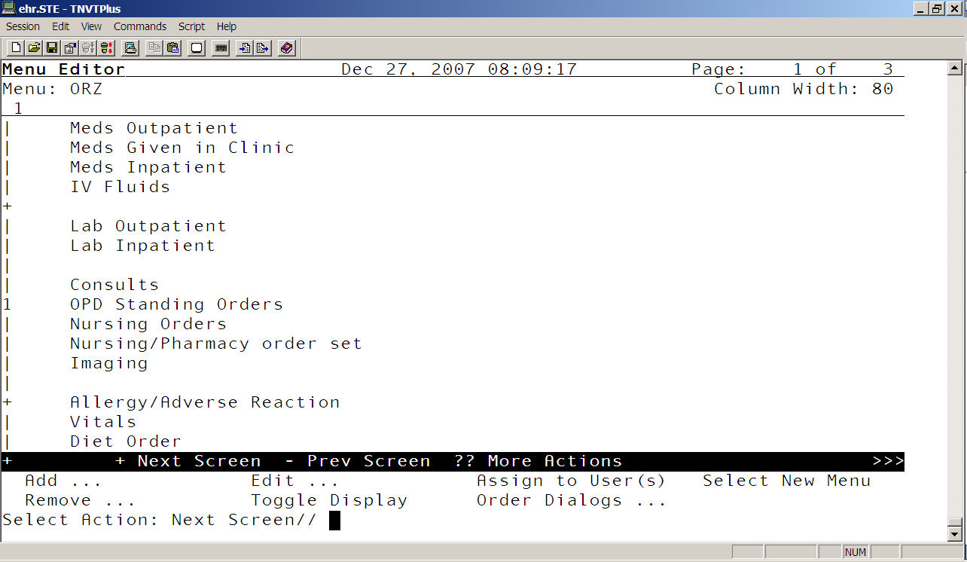
OIC Create/Modify Orderable Items
DESCRIPTION: This option lets you create or change the things that are
orderable via generic text orders at your site. You create new orderable for your nursing orders
How it works:
Create/Modify Orderable Items
Type of Orderable: ??
Choose from:
ACTIVITY
NURSING
OTHER HOSPITAL SERVICES
Type of Orderable: nursing
Select ORDERABLE ITEMS: respiratory treatments
Are you adding 'respiratory treatments' as
a new ORDERABLE ITEMS (the 3308TH)? No// y (Yes)
NAME: respiratory treatments Replace

PAR Menu Parameters ...
CON New Consult Dialog Default (orwdx new consult)
This option allows CAC to change the generic order dialog in the new consult button to another menu.

DEMO HOSPITAL RPMS-EHR Management Version 1.1
New Consult Dialog Default

New consult dialog default may be set for the following:

1 User USR [choose from NEW PERSON]
2 Location LOC [choose from HOSPITAL LOCATION]
3 System SYS [DEMO-HO.IHS.GOV]
4 Package PKG [ORDER ENTRY/RESULTS REPORTING]

Enter selection: 4 Package ORDER ENTRY/RESULTS REPORTING

Parameters set for 'Package' may be replaced if ORDER ENTRY/RESULTS REPORTING
is installed in this account.

Setting New consult dialog default for Package: ORDER ENTRY/RESULTS REPORTING
Order Dialog: GMRCOR CONSULT//

In GUI: This parameter edits the menu you get when you click on the new consult button.
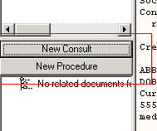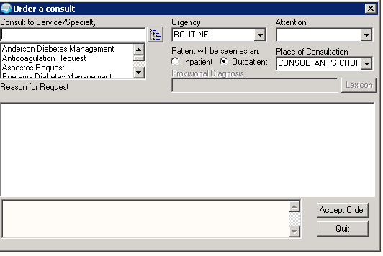

INP Write Orders List (Inpatient) (orwor write orders list)
This option allows you to put order dialogs by sequence so that these menus are available in the GUI. If you use this parameter to add your menus to your GUI then you will not use the “write orders list (outpatient) parameter.

How it works:

DEMO HOSPITAL RPMS-EHR Management Version 1.1
Write Orders List (Inpatient)

Write Orders (Inpatient) may be set for the following:

1 User USR [choose from NEW PERSON]
2 Location LOC [choose from HOSPITAL LOCATION]
2.3 Service SRV [choose from SERVICE/SECTION]
2.7 Division DIV [choose from INSTITUTION]
3 System SYS [DEMO-HO.IHS.GOV]
4 Package PKG [ORDER ENTRY/RESULTS REPORTING]

Enter selection: 4 Package ORDER ENTRY/RESULTS REPORTING

Parameters set for 'Package' may be replaced if ORDER ENTRY/RESULTS REPORTING
is installed in this account.

Setting Write Orders (Inpatient) for Package: ORDER ENTRY/RESULTS REPORTING
Select Sequence: ?

Sequence Value
-------- -----
20 GMRAOR ALLERGY ENTER/EDIT
30 FHW1
52 PSJ OR PAT OE
55 PSO OERR
58 PSJI OR PAT FLUID OE
60 LR OTHER LAB TESTS
70 RA OERR EXAM
80 GMRCOR CONSULT
85 GMRCOR REQUEST
90 GMRVOR
99 OR GXTEXT WORD PROCESSING ORDER

MED New Med Dialog Default (orwdx new med)
This parameter allows you to attach an order dialog other then the one that comes from package.

How it works:

DEMO HOSPITAL RPMS-EHR Management Version 1.1
New Med Dialog Default

New Med Dialog may be set for the following:

1 User USR [choose from NEW PERSON]
3 System SYS [DEMO-HO.IHS.GOV]
4 Package PKG [ORDER ENTRY/RESULTS REPORTING]

Enter selection: 4 Package ORDER ENTRY/RESULTS REPORTING

Parameters set for 'Package' may be replaced if ORDER ENTRY/RESULTS REPORTING
is installed in this account.

----- Setting New Med Dialog for Package: ORDER ENTRY/RESULTS REPORTING -----
Select Patient Status: out Outpatient

Patient Status: Outpatient// Outpatient
Order Dialog: PSO OERR// PSO OERR
Select Patient Status: inp Inpatient

Patient Status: Inpatient// Inpatient
Order Dialog: PSJ OR PAT OE// PSJ OR PAT OE

*I added a different menu then the one under system, very important never alter the package*

DEMO HOSPITAL RPMS-EHR Management Version 1.1
New Med Dialog Default

New Med Dialog may be set for the following:

1 User USR [choose from NEW PERSON]
3 System SYS [DEMO-HO.IHS.GOV]
4 Package PKG [ORDER ENTRY/RESULTS REPORTING]

Enter selection: 3 System DEMO-HO.IHS.GOV

------------ Setting New Med Dialog for System: DEMO-HO.IHS.GOV ------------
Select Patient Status: out Outpatient

Patient Status: Outpatient// Outpatient
Order Dialog: ORZ// ORZ

In GUI:
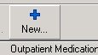
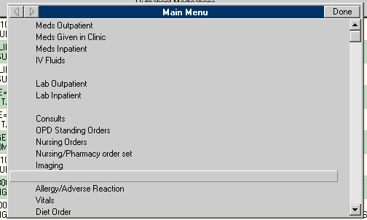

OUT Write Orders List (Outpatient) (orwdx write order list)
This option allows you to put order dialogs by sequence so that these menus are available in the GUI. If you use this parameter to add your menus to your GUI then you will not use the “write orders list (inpatient) parameter.

How it works:

DEMO HOSPITAL RPMS-EHR Management Version 1.1
Write Orders List (Outpatient)

Menu for Write Orders List may be set for the following:

2 User USR [choose from NEW PERSON]
4 Location LOC [choose from HOSPITAL LOCATION]
5 Service SRV [choose from SERVICE/SECTION]
7 Division DIV [DEMO HOSPITAL]
8 System SYS [DEMO.MEDSPHERE.COM]

Enter selection: 8 System DEMO.MEDSPHERE.COM

----- Setting Menu for Write Orders List for System: DEMO.MEDSPHERE.COM -----
Order Dialog: ORZM MAIN MENU//

PRO New Procedure Dialog Default (orwdx new procedure)
This option allows CAC to change the generic order dialog in the new procedure button to another menu. We do not use procedures for IHS.

How it works:
New Procedure Dialog Default

New procedure dialog default may be set for the following:

1 User USR [choose from NEW PERSON]
2 Location LOC [choose from HOSPITAL LOCATION]
3 System SYS [DEMO.MEDSPHERE.COM]
4 Package PKG [ORDER ENTRY/RESULTS REPORTING]

Enter selection: 4 Package ORDER ENTRY/RESULTS REPORTING

Parameters set for 'Package' may be replaced if ORDER ENTRY/RESULTS REPORTING
is installed in this account.

Setting New procedure dialog default for Package: ORDER ENTRY/RESULTS REPORTIN
G
Order Dialog: GMRCOR REQUEST//

STY Order Menu Style (orwdxm order menu style)
This parameter takes does not show mnemonics in your order dialogs. If when you create menus you use mnemonic then you might want to consider changing this parameter system wide to not include mnemonic with your orders.

How it works:

DEMO HOSPITAL RPMS-EHR Management Version 1.1
Order Menu Style

Order Menu Style may be set for the following:

2 System SYS [DEMO.MEDSPHERE.COM]
4 Package PKG [ORDER ENTRY/RESULTS REPORTING]

Enter selection: 4 Package ORDER ENTRY/RESULTS REPORTING

Parameters set for 'Package' may be replaced if ORDER ENTRY/RESULTS REPORTING
is installed in this account.

---- Setting Order Menu Style for Package: ORDER ENTRY/RESULTS REPORTING ----
Menu Style: Mnemonics Included//

Select the style of ordering menu to be used with the GUI.

Select one of the following:

0 Mnemonics Included
1 No Mnemonics
2 Reserved1
3 Reserved2
PMT Create/Modify Prompts
DESCRIPTION: This option lets you create or change prompts for generic order dialogs. Most of the prompts found in this menu are un-editable. CAC will not be using this menu.

PRI Assign Primary Order Menu (or add orders menu
DESCRIPTION: This option is used to assign a primary order menu to users. A primary order menu must be assigned to each user in order to add orders using OE/RR. Do not edit this parameter.

How it works:
Assign Primary Order Menu

Add New Orders may be set for the following:

1 User USR [choose from NEW PERSON]
4 Location LOC [choose from HOSPITAL LOCATION]
5 Service SRV [choose from SERVICE/SECTION]
6 Division DIV [DEMO HOSPITAL]
7 System SYS [DEMO.MEDSPHERE.COM]
9 Package PKG [ORDER ENTRY/RESULTS REPORTING]

Enter selection: 9 Package ORDER ENTRY/RESULTS REPORTING

Parameters set for 'Package' may be replaced if ORDER ENTRY/RESULTS REPORTING
is installed in this account.

----- Setting Add New Orders for Package: ORDER ENTRY/RESULTS REPORTING -----
Add Order Menu Default: OR ADD MENU CLINICIAN//

PRT Convert Protocols
DESCRIPTION: This option lets you convert any protocols that didn't get processed automatically or successfully by the CPRS order menu conversion, for use on Add Orders menus. Not useful to CAC. You need programming skills to know what to do here.

QOC Create/Modify Quick Orders
DESCRIPTION: This option lets you create or change quick orders. The dialog for creating a quick order is similar to a dialog for entering an order. The responses you enter will become the pre-defined responses for this quick order. End users will have the opportunity to edit these pre-defined responses, if desired.

QOR Create/Modify QO Restrictions
DESCRIPTION: This option allows a site to mark orderable items for use within pre- defined quick orders only; these items will not be selectable when ordering via standard package order dialogs.

How it works:

Select an ORDERABLE ITEM (meds or labs only): abilify
Select the type of usage for which you wish to restrict ordering of this item.
Usage: OUTPATIENT MEDICATIONS
Select the type of usage for which you wish to restrict ordering of this item.
Choose from:
OUTPATIENT MEDICATIONS
PHARMACY
UNIT DOSE MEDICATIONS
QO ONLY: YES
Enter YES if this item should only be orderable via quick orders. This field determines if the item may be ordered via the regular order dialog for this Set, or only via predefined quick orders.
Choose from:
1 YES

SET Create/Modify Order Sets
DESCRIPTION: This option lets you create or modify order sets, by combining a group of related quick orders into a single item.

SRC Search/Replace Components
DESCRIPTION: This option lets you search for specific components on menus and replace or delete one or more instances of these components. Components include: quick orders, order sets, prompts, protocols, actions, etc.

How it works:
Ancestors of LR OTHER LAB TESTS
Name Type
-------------------------------------------------------------------------------
1 OR ADD MENU CLINICIAN menu
2 ORZM MAIN MENU menu
3 ORZM LAB ORDERS menu
-------------------------------------------------------------------------------
Replace LR OTHER LAB TESTS with: ?

Enter the name of the item you wish to replace this one with, or @ to
remove this item; to quit without changing anything, press <return>.

SRO Search/Replace Orderables
DESCRIPTION: This option lets you search for specific orderable items saved as responses within quick orders; a new orderable item may be selected to automatically replace it, as well.

How it works:

Search for: HEMATOCRIT HCT

Quick Orders and Dialogs containing HCT
-------------------------------------------------------------------------------
1 LRZ HCT
2 LRZ HCT INPT
3 LRZ HCT STAT
-------------------------------------------------------------------------------
Replace with: hct
Replace in: 1-3// 1

Are you ready? NO// y YES

Replacing HCT with HCT in:
LRZ HCT ...done.

*This option would work great for lab. Whenever they inactivate a lab test and this lab test is used in a menu, they can search for every instance where that lab shows up and then replace that lab with the new lab*

OCX Order Check Configuration ...
This menu option allow you to configure order check for the system

ACT Activate/Inactivate Rules
This menu is used for activating or inactivating individual order checks.

How it works:
Select ORDER CHECK RULE NAME: abnorMAL LAB RESULTS
STATUS: ACTIVE//
Choose from:
0 ACTIVE
1 INACTIVE

COM Compile Rules
I could not find a use for this menu. It send info to a mail group but could not find the mail group it send it to.

Compile Rules
Do you want to queue the compiler to run ? NO// y YES

Expert system compiler queued to run in 10 seconds.
You will be sent a Mailman bulletin when it has finished.

(e-mail info)

From: Mosely, Elvira (IHS/PHX) [mailto:Elvira.Mosely@ihs.gov]
Sent: Thursday, December 27, 2007 12:06 PM
To: Mary Hager
Subject: question

Mary
What is this option used for?
COM Compile Rules [BEHOORCX RUN COMPILER]

From: Hager, Mary (IHS Contact)

Order checks. It recompiles them. You shouldn’t need to use this since they recompile automatically if you edit anything

ENA Enable/Disable Order Checking System (ork system enable/disable)
DESCRIPTION: Determines if any order checking will occur. 'E' or 'Enable' indicates order checking is enabled and running. 'D' or 'Disabled' indicates order checking is disabled and not running. Can be set at the institution, System or Package level.

How it works:

DEMO HOSPITAL RPMS-EHR Management Version 1.1
Enable/Disable Order Checking System

Enable or disable order checking system. may be set for the following:

1 Division DIV [DEMO HOSPITAL]
2 System SYS [DEMO.MEDSPHERE.COM]
3 Package PKG [ORDER ENTRY/RESULTS REPORTING]

Enter selection: 3 Package ORDER ENTRY/RESULTS REPORTING

Parameters set for 'Package' may be replaced if ORDER ENTRY/RESULTS REPORTING
is installed in this account.

Setting Enable or disable order checking system. for Package: ORDER ENTRY/RESU
LTS REPORTING
Value: Disable// ?

Enter 'Enable/E' for order checking, 'Disable/D' to stop order checking.

Select one of the following:

E Enable
D Disable

INQ Expert System Inquiry
This menu is more for programmers. Really does not apply to CAC.

Expert System Display

ORDER CHECK EXPERT version 1.01 released OCT 29,1998

Rule Display a Rule

Element Display an Element

Field Display a Data Field

Option List -> Element, Field, Rule

PAR Order Check Parameters
This option configures the order checks for the system.

How it works:
CON Creatinine Date Range for Contrast Media Orders (ork contrast media creatine)
CTH CT Scanner Height Limit (ork ct limit ht)
CTW CT Scanner Weight Limit (ork ct limit wt)
DAN Set Clinical Danger Level (ork clinical danger levels)
DBG Enable/Disable Debug Message Logging (ork debug enable/disable)
DPL Lab Duplicate Order Range (ork dup order range lab)
DPO Orderable Item Duplicate Order Range (ork dup order range oi)
DPR Radiology Duplicate Order Range (ork dup order range radiology)
EDT Mark Order Checks Editable by User (ork editable by user)
ENA Enable/Disable an Order Check (ork system enable/disable)
GLU Creatinine Date Range for Glucophage-Lab Results (ork glucophage creatine)
LCL Edit Local Terms
MRH MRI Scanner Height Limit (ork mri limit ht)
MRW MRI Scanner Weight Limit (ork mri limit wt)
PLY Number of Medications for Polypharmacy (ork polypharmacy)
USR Order Checks a User Can Receive

GLU Creatinine date range for glucophage: this is where you are going to put how far back you will look for this test.

LCL Edit Terms: This is where you are going to attach your local labs to your order check

PLY Number of medications for polypharmacy: This menu is where you are going to put a number for what constitute polypharmacy for your facility

USR Order Checks a User can Receive: This where you can check the order check that someone can receive.

DEMO HOSPITAL RPMS-EHR Management Version 1.1
Order Checks a User Can Receive
Enter user's name: USER,DEMO// DU

Would you like help understanding the list of order checks? No// (No)

This will take a moment or two, please stand by............................
DEVICE: HOME// VIRTUAL

Order Check List for USER,DEMO Page: 1

Order Check ON/OFF For This User and Why
-------------------------------- ---------------------------------------------
ALLERGY-CONTRAST MEDIA INTERAC ON OERR value is Enabled
ALLERGY-DRUG INTERACTION ON OERR value is Enabled
AMINOGLYCOSIDE ORDERED OFF System value is Disabled
BIOCHEM ABNORMALITY FOR CONTRA ON OERR value is Enabled
CLOZAPINE APPROPRIATENESS ON OERR value is Enabled
CRITICAL DRUG INTERACTION ON OERR value is Enabled
CT & MRI PHYSICAL LIMITATIONS ON OERR value is Enabled
DANGEROUS MEDS FOR PT > 64 ON No value found
DISPENSE DRUG NOT SELECTED ON OERR value is Enabled
DUPLICATE DRUG CLASS ORDER ON OERR value is Enabled
DUPLICATE DRUG ORDER ON OERR value is Enabled
DUPLICATE OPIOID MEDICATIONS OFF OERR value is Disabled
DUPLICATE ORDER ON OERR value is Enabled
ERROR MESSAGE ON OERR value is Enabled
ESTIMATED CREATININE CLEARANCE ON OERR value is Enabled
GENERIC RESULTS ON No value found
GLUCOPHAGE-CONTRAST MEDIA ON OERR value is Enabled
GLUCOPHAGE-LAB RESULTS ON OERR value is Enabled
LAB ORDER FREQ RESTRICTIONS ON OERR value is Enabled
MISSING LAB TESTS FOR ANGIOGRA ON OERR value is Enabled
NO ALLERGY ASSESSMENT OFF OERR value is Disabled
ORDER CHECKING NOT AVAILABLE ON OERR value is Enabled
POLYPHARMACY ON OERR value is Enabled
RECENT BARIUM STUDY ON OERR value is Enabled
RECENT ORAL CHOLECYSTOGRAM ON OERR value is Enabled
RENAL FUNCTIONS OVER AGE 65 ON OERR value is Enabled
SIGNIFICANT DRUG INTERACTION ON OERR value is Enabled

PAR Order Parameters ...
HLD Disable Hold/Unhold Actions in EHR (orwor disable hold orders)
This parameter will prevent orders from being placed on hold.

How it works:

DEMO HOSPITAL RPMS-EHR Management Version 1.1
Disable Hold/Unhold Actions in EHR

Disable Hold/Unhold Actions in GUI may be set for the following:

5 System SYS [DEMO.MEDSPHERE.COM]
9 Package PKG [ORDER ENTRY/RESULTS REPORTING]

Enter selection: 9 Package ORDER ENTRY/RESULTS REPORTING

Parameters set for 'Package' may be replaced if ORDER ENTRY/RESULTS REPORTING
is installed in this account.

Setting Disable Hold/Unhold Actions in GUI for Package: ORDER ENTRY/RESULTS RE
PORTING
Disable Hold: NO// ?

Enter yes if using the Hold/Unhold actions should be disallowed in GUI.

MSC Miscellaneous Parameters
This parameter configures your ordering system

DEMO HOSPITAL RPMS-EHR Management Version 1.1
Miscellaneous Parameters

Miscellaneous OE/RR Definition for System: DEMO.MEDSPHERE.COM
------------------------------------------------------------------------------
Active Orders Context Hours 24
Allow Clerks to act on Med Orders NO
Auto Unflag YES
Confirm Provider YES (Exclude ORES)
Default Provider
Error Days 3
New Orders Default Sign & Release
Restrict Requestor YES (ORELSE & OREMAS)
Review on Patient Movement
Show Lab # YES
Show Status Description YES
Signature Default Action Release w/o Signature
Signed on Chart Default NO

ORD Disable Ordering in EHR (orwor disable ordering)
This parameter disables writing orders and taking actions on orders in the GUI.

DEMO HOSPITAL RPMS-EHR Management Version 1.1
Disable Ordering in EHR

Disable Ordering in GUI may be set for the following:

2 User USR [choose from NEW PERSON]
5 System SYS [DEMO.MEDSPHERE.COM]
10 Package PKG [ORDER ENTRY/RESULTS REPORTING]

Enter selection: 10 Package ORDER ENTRY/RESULTS REPORTING

Parameters set for 'Package' may be replaced if ORDER ENTRY/RESULTS REPORTING
is installed in this account.

Setting Disable Ordering in GUI for Package: ORDER ENTRY/RESULTS REPORTING
Disable Ordering: NO// ?

Enter 'Yes' if you wish to disable ordering and order action in the GUI.

RSN Edit DC Reasons
DESCRIPTION: This option allows access to the Order Reason file to enter or edit reasons for discontinuing an order.

DEMO HOSPITAL RPMS-EHR Management Version 1.1
Edit DC Reasons

Select DC REASON: ?
Answer with ORDER REASON NUMBER, or NAME, or SYNONYM
Do you want the entire ORDER REASON List? y (Yes)
Choose from:
7 Duplicate Order
8 Discharge
9 Transfer
10 Treating Specialty Change
11 Admit
14 Requesting Physician Cancelled
15 Obsolete Order
16 Entered in error
17 Death
20 Surgery
21 Pass
22 ASIH

You may enter a new ORDER REASON, if you wish
Answer must be 3-40 characters in length.

Select DC REASON: other
Are you adding 'other' as a new ORDER REASON? No// y (Yes)
NAME: other//
SYNONYM: oth
INACTIVE:
NATURE OF ACTIVITY: 6 DUPLICATE
Enter the nature of order activity for this reason. This field is used to categorize DC reasons into types that OE/RR can take action on. The actions and types are defined in the Nature of order file.
Answer with NATURE OF ORDER NUMBER, or NAME, or CODE
Do you want the entire 11-Entry NATURE OF ORDER List? y (Yes)
Choose from:
1 WRITTEN W
2 VERBAL V
3 TELEPHONED P
4 SERVICE CORRECTION S
5 POLICY I
6 DUPLICATE D
7 REJECTED X
8 ELECTRONICALLY ENTERED E
9 AUTO A
10 CHANGED C
11 MAINTENANCE M

UOV Set Unsigned Orders View on Exit (or unsigned orders on exit)
DESCRIPTION: This option may be used to set the default view of unsigned orders that ORES key holders will see when exiting a patient's chart; possible views are only those orders entered during the current session, all of the current user's unsigned orders, or all unsigned orders for the patient.

DEMO HOSPITAL RPMS-EHR Management Version 1.1
Set Unsigned Orders View on Exit

Unsigned Orders View on Exit may be set for the following:

1 User USR [choose from NEW PERSON]
3 Service SRV [choose from SERVICE/SECTION]
5 Division DIV [DEMO HOSPITAL]
7 System SYS [DEMO.MEDSPHERE.COM]
9 Package PKG [ORDER ENTRY/RESULTS REPORTING]

Enter selection: 9 Package ORDER ENTRY/RESULTS REPORTING

Parameters set for 'Package' may be replaced if ORDER ENTRY/RESULTS REPORTING
is installed in this account.

Setting Unsigned Orders View on Exit for Package: ORDER ENTRY/RESULTS REPORTIN
G
UNSIGNED ORDERS VIEW ON EXIT: MY UNSIGNED ORDERS//
Enter the unsigned orders view to present ORES key holders on exit.

Select one of the following:

0 NEW ORDERS ONLY
1 MY UNSIGNED ORDERS
2 ALL UNSIGNED ORDERS

VER Enable/Disable Order Verify Actions (orwor enable verify)
This parameter controls whether nurses are allowed to verify orders in the
GUI. This parameter applies to the "Verify" and "Chart Review" on the Actions menu on the Order tab.

This parameter let nurses verify an order when they highlight the order and select verify. Notice below it put the nurse initial under the nurse column.

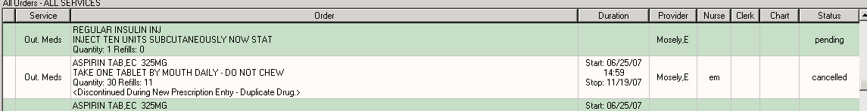

DEMO HOSPITAL RPMS-EHR Management Version 1.1
Enable/Disable Order Verify Actions

Enable/Disable Order Verify Actions may be set for the following:

1 User USR [choose from NEW PERSON]
5 System SYS [DEMO.MEDSPHERE.COM]
10 Package PKG [ORDER ENTRY/RESULTS REPORTING]

Enter selection: 10 Package ORDER ENTRY/RESULTS REPORTING

Parameters set for 'Package' may be replaced if ORDER ENTRY/RESULTS REPORTING
is installed in this account.

Setting Enable/Disable Order Verify Actions for Package: ORDER ENTRY/RESULTS R
EPORTING
Verify Action Status:

The default value is 0, which allows nurses to verify orders only
when ordering is enabled. To allow nurses to verify orders when ordering
is disabled, set the value to 1. To never allow the verify actions, set
the value to 2.

PRN Print/Report Parameters ...
DESCRIPTION: This menu is for editing print parameters. It should be
available to the clinical coordinator and IRM Staff. Set up your print format here.

CHT Chart Copy Parameters
HOS Print Parameters for Hospital
LOC Print Parameters for Wards/Clinics
REQ Requisition/Label Parameters
SUM Summary Report Parameters
SVC Service Copy Parameters
WRK Work Copy Parameters

RPT Order Reports ...
MON Performance Monitor Report
DESCRIPTION: This option produces a report showing the number of orders entered by provider. The report includes a detailed listing as well as a summary. The detail listing includes pertinent information about each order associated with the listed provider. The summary report shows the number of orders entered for a provider, the number of orders entered by an ORES key holder, the percentage of orders entered by an ORES key holder for the given provider and a break down of the orders by nature of order for those that were entered by a non-ORES key holder.

How it works:
DEMO HOSPITAL RPMS-EHR Management Version 1.1
Performance Monitor Report
Enter starting date: t-200 (JUN 10, 2007)
Enter ending date: t (DEC 27, 2007)
Do you want ALL providers to appear on this report? Y// ES

Select one of the following:

A All orders
P Pharmacy orders only

Select order category: P// al All orders

Select one of the following:

I Inpatient
O Outpatient
B Both

Select patient status: B// o Outpatient

Select one of the following:

S Summary (includes provider details)
D Detail (includes order details)
B Both (Summary & Detail)
T Summary Report Totals Only (no provider details)

Select report: S// b Both (Summary & Detail)
DEVICE: HOME// VIRTUAL

CPRS Performance Monitor - Detailed Report Dec 27, 2007 PAGE 1
Selected Date Range: 6/10/07 to 12/27/07
Sort criteria: OUTPATIENTS/ALL ORDERS ENTERED
ORDER ORD PATIENT BY HAS
DATE ORDER # PAT ID 1st ORD ITEM TYPE LOCATION PACKAGE ORES?
--------------------------------------------------------------------------------

PROVIDER: USER,DEMO

6/13/07 139 D ELE PEDIATRICS ADVERSE REA Y
6/13/07 140 D ACETAMINOPHE ELE PEDIATRICS OUTPATIENT Y
8/24/07 141 D PENICILLIN P ELE PEDIATRICS OUTPATIENT Y
8/24/07 146 D4838 IBUPROFEN SU ELE PEDIATRICS OUTPATIENT Y

PROVIDER: ZIPPER,KIMBERLY

9/7/07 155 D7867 HGB ELE DIABETES LAB SERVICE N
9/7/07 156 D7867 LIPID PROFIL ELE DIABETES LAB SERVICE N
9/7/07 157 D7867 HEMOGLOBIN A ELE DIABETES LAB SERVICE N
9/7/07 158 D7867 MICROALBUMIN ELE DIABETES LAB SERVICE N
9/7/07 159 D7867 TSH (ANMC) ELE DIABETES LAB SERVICE N
9/7/07 163 D7867 ASPIRIN TAB, ELE DIABETES OUTPATIENT N
9/7/07 164 D7867 LISINOPRIL T ELE DIABETES OUTPATIENT N
9/7/07 165 D7867 LOSARTAN TAB ELE DIABETES OUTPATIENT N

CPRS Performance Monitor - Summary Report Dec 27, 2007 PAGE 3
Selected Date Range: 6/10/07 to 12/27/07
Sort criteria: OUTPATIENTS/ALL ORDERS BREAKDOWN OF ORDERS
PROVIDER PROVIDER NOT SELF ENTERED
PROVIDER UNIVERSE DEA/STU/POL ORDERS ENTERED % WR/VE/TE/EL
--------------------------------------------------------------------------------
USER,DEMO
Outpt Tot 4 4 4 100%
Sub-tot 4 4 4 100%
ZIPPER,KIMBERLY
Outpt Tot 8 8 0 0% 0/0/0/8
Sub-tot 8 8 0 0%
------------------------------------------------------------------------------
OUTPT 12 0/0/0 12 4 33% 0/0/0/8
TOTAL 12 0/0/0 12 4 33% 0/0/0/8

NAT Search orders by Nature or Status
DESCRIPTION: This option will allow the user to search orders for a specific NATURE OF ORDER or order STATUS. There are two formats available. one is a detailed display that is printed in real time as the order number that meets the search criteria is encountered. There is no further sort capability for this format. The second format is the columnar format which will allow the sort by ENTERING person or by SERVICE/SECTION. This format works best if sending the output to a 132 column compressed printer or to the BROWSER device.

UNS Unsigned orders search
DESCRIPTION: This option will allow the user to search for either RELEASED but UNSIGNED orders or just UNSIGNED orders and sort them by Service/section, Provider, Patient, or Location. A start date entry will allow the site to ignore unsigned orders that fall within their allowed grace period. For example: the site allows the clinician 48 hours to sign unsigned orders, you would enter T-2 for a start date. A stop date entry will allow the site to ignore orders older than the date entered. An example of this would be, if you wanted to ignore unsigned orders that were placed prior to CPRS and you installed CPRS on Jan 1, 1999, you would enter 010199.

How it works:
Unsigned Orders Search
This report is formatted for a 132 column output.

Select one of the following:

1 Released/Unsigned
2 Unsigned
3 Unsigned/Unreleased

Enter the type of orders to search: 1 Released/Unsigned

Select one of the following:

1 Service/Section
2 Provider
3 Patient
4 Location
5 Entered By
6 Division

Enter the sort criteria: 2 Provider
Would you like a specific Provider? NO//
Enter a starting date: t-200 (JUN 10, 2007)
Enter an ending date: t (DEC 27, 2007)
Print summary only ? NO//
DEVICE: HOME// VIRTUAL

Report Date: Dec 27, 2007@10:00:34 Sort Range From: Jun 10, 2007 To: Dec 27,
2007

List of RELEASED but UNSIGNED orders by PROVIDER

PROVIDER ENTERED BY PATIENT SSN
STATUS
ORDER #
ORDER DATE
--------------------------------------------------------------------------------

No unsigned orders found

PAT Patient Context Configuration ...
ALS Ignore Aliases in Patient Lookup (BEHOPTCX IGNORE ALIASES)
If set to YES, any aliases encountered in the primary index of the patient file
are ignored.
DMO Allow Viewing of Demo Patients Only (behoptcx demo mode)
Allow viewing of demo patient only. This parameter would be useful when training on a live database. You can assign your student demo patients only.

How it works:

DEMO HOSPITAL RPMS-EHR Management Version 1.1
Allow Viewing of Demo Patients Only

Allow viewing of demo patients only may be set for the following:

100 User USR [choose from NEW PERSON]
200 Division DIV [DEMO HOSPITAL]
300 System SYS [DEMO.MEDSPHERE.COM]

Enter selection: 300 System DEMO.MEDSPHERE.COM

Setting Allow viewing of demo patients only for System: DEMO.MEDSPHERE.COM
Limit to demo patients only?: ??

If yes, the only demo patients may be selected.

DTL Set Logic for Patient Detail View (behoptcx detail report)
Set the logic of what information you get from patient detail button. You can change the report if you do not want this one. The CAC manual has how to do it.

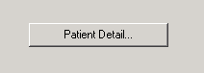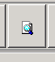

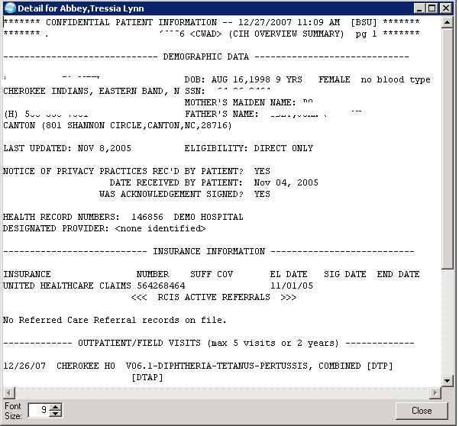

LST Recall Last Selected Patient (behoptcx recall last)
This parameter if set will recall the last patient selected by the user before thy signed off.

DEMO HOSPITAL RPMS-EHR Management Version 1.1
Recall Last Selected Patient

Recall last selected patient may be set for the following:

100 User USR [choose from NEW PERSON]
200 Division DIV [DEMO HOSPITAL]
300 System SYS [DEMO.MEDSPHERE.COM]

Enter selection: 300 System DEMO.MEDSPHERE.COM

---- Setting Recall last selected patient for System: DEMO.MEDSPHERE.COM ----
Recall last selected patient?: YES// ??

If yes, the patient context is set to the last patient selected upon
startup.

RNG Default Date Ranges for Patient Selection Dialog (behoptpl date ranges)
Do not edit this parameter leave it along.

DEMO HOSPITAL RPMS-EHR Management Version 1.1
Default Date Ranges for Patient Selection Dialog

-------- Setting Default date ranges: for System: DEMO.MEDSPHERE.COM --------
Edit Value?: Y// ??

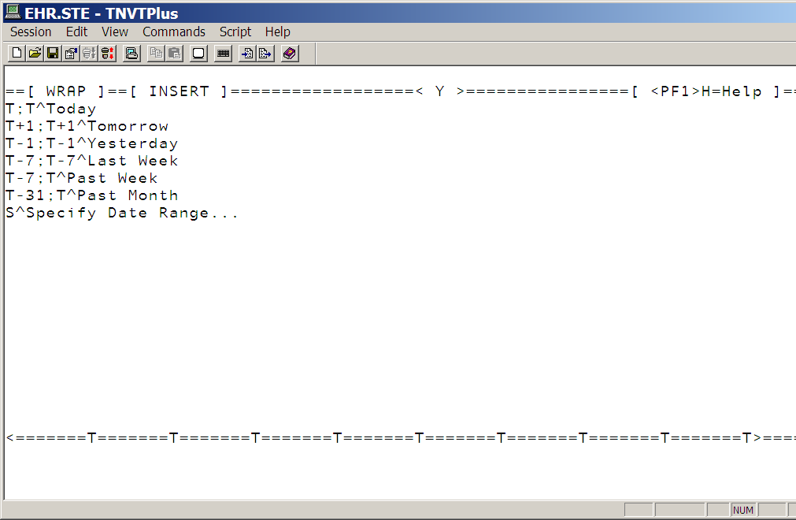
Controls this
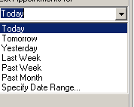

TEA Team List Management Menu ...
This menu allows you to create team list. You use these team list for consults.

DEMO HOSPITAL RPMS-EHR Management Version 1.1
Team List Management Menu

CRE Create/Add to Team List
DEL Delete Existing List(s)
DPT Display Patients Linked to a User via Teams
DUS Display User's Teams
EXA Examine/Print Existing List(s)
RAL Remove Autolinks
REN Rename Existing List(s)
RPA Remove Patients from a List
RPR Remove Providers from a List

PHX Personal Health Hx Configuration ...
DRE Disable Reproductive History Editing (bgo disable rep hist editing)
This parameter takes away the ability to edit or enter personal history.

DEMO HOSPITAL RPMS-EHR Management Version 1.1
Disable Reproductive History Editing

Disable Reproductive History Editing may be set for the following:

100 User USR [choose from NEW PERSON]
200 Class CLS [choose from USR CLASS]

Enter selection: 100 User NEW PERSON
Select NEW PERSON NAME: user,d USER,DEMO DU

----- Setting Disable Reproductive History Editing for User: USER,DEMO -----
Value: y YES
I took away the ability to edit
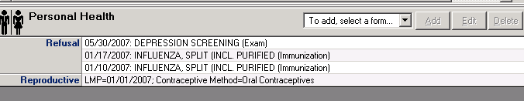

PLS Problem List Configuration ...
DPE Disable Problem List Editing (bgo disable prob list editing)
Disable the ability to enter or edit problems in problem list.

DEMO HOSPITAL RPMS-EHR Management Version 1.1
Disable Problem List Editing

Disable Problem List Editing may be set for the following:

100 User USR [choose from NEW PERSON]
200 Class CLS [choose from USR CLASS]

Enter selection: 100 User NEW PERSON
Select NEW PERSON NAME: USER,BSTUDENT

------- Setting Disable Problem List Editing for User: USER,BSTUDENT -------
Value: y YES
Enter either 'Y' or 'N'.

I no longer have the ability to edit problem list
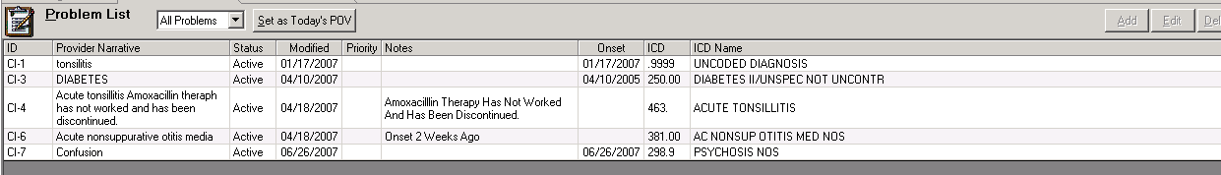

FLT Default Filter for Problem List (bgo pl default filter)
This parameter set what you are going to see on your problem list.

Below the system has no filter so you see everything.
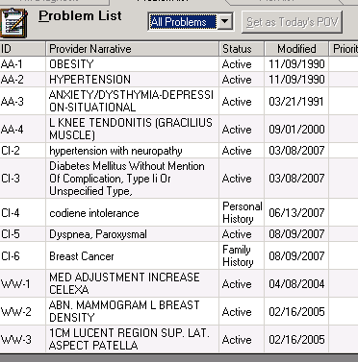

I changed the filter so that I only get active problems
DEMO HOSPITAL RPMS-EHR Management Version 1.1
Default Filter for Problem List

Problem List Default Filter may be set for the following:

10 User USR [choose from NEW PERSON]
20 Class CLS [choose from USR CLASS]
30 Division DIV [choose from INSTITUTION]
90 System SYS [DEMO-HO.IHS.GOV]

Enter selection: 90 System DEMO-HO.IHS.GOV

------ Setting Problem List Default Filter for System: DEMO-HO.IHS.GOV ------
Default filter: ??

This parameter specifies which problem list filter should be the initial
default.

Default filter: ?

Select which filter should be the default.

Select one of the following:

0 ALL
1 ACTIVE
2 INACTIVE
3 PERSONAL HX
4 FAMILY HX

Default filter: 1 ACTIVE

Now my problem list brings in the active orders only
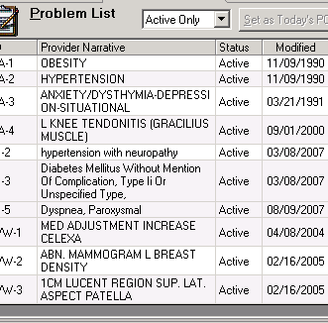

IPH Include Personal Hist Problem w/Active (bgo pl include pers hist w act)
This parameter brings in the personal history along with all your active problems.

DEMO HOSPITAL RPMS-EHR Management Version 1.1
Include Personal Hist Problem w/Active

Include Personal Hist Problem w/Active may be set for the following:

10 User USR [choose from NEW PERSON]
20 Class CLS [choose from USR CLASS]
30 Division DIV [choose from INSTITUTION]
90 Package PKG [BGO COMPONENTS]

Enter selection: 90 Package BGO COMPONENTS

Parameters set for 'Package' may be replaced if BGO COMPONENTS
is installed in this account.

Setting Include Personal Hist Problem w/Active for Package: BGO COMPONENTS

Value: YES

In GUI
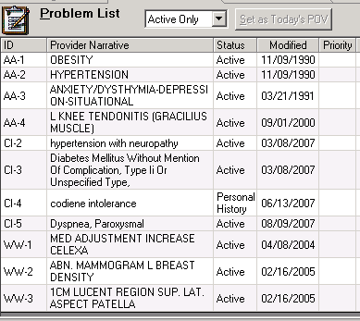

POV POV Configuration ...
DPE Disable POV Editing (bgo disable pov editing)
This parameter disables the ability to enter or edit POV.

Disable POV Editing

Disable POV Editing may be set for the following:

100 User USR [choose from NEW PERSON]
200 Class CLS [choose from USR CLASS]

Enter selection: 100 User NEW PERSON
Select NEW PERSON NAME: user,b USER,BSTUDENT

------------ Setting Disable POV Editing for User: USER,BSTUDENT ------------
Value: y YES

In GUI
I no longer have the ability to enter POV’s
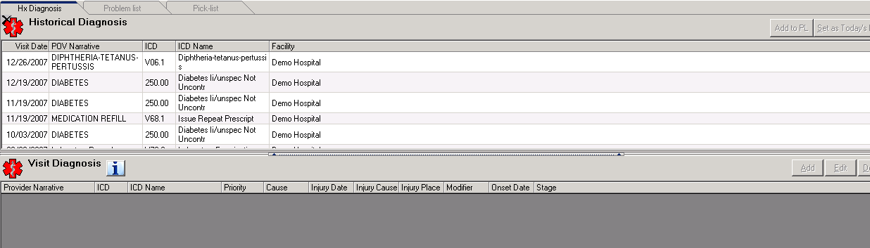

MAX Maximum Entries Shown in POV History (bgo pov hist max entries)
This parameter edits the amount of entries shown in POV history

Before editing this parameter
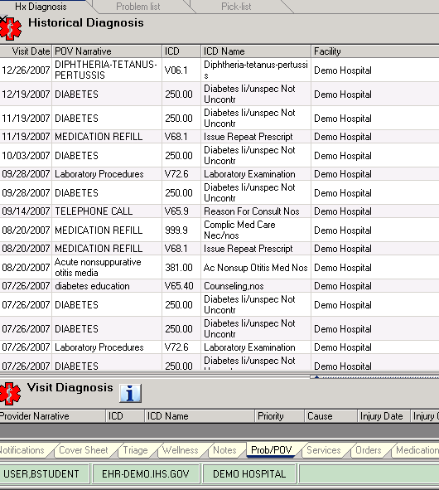

DEMO HOSPITAL RPMS-EHR Management Version 1.1
Maximum Entries Shown in POV History

Maximum Entries Shown in POV History may be set for the following:

10 User USR [choose from NEW PERSON]
20 Class CLS [choose from USR CLASS]
30 Division DIV [choose from INSTITUTION]
40 Package PKG [BGO COMPONENTS]

Enter selection: 40 Package BGO COMPONENTS

Parameters set for 'Package' may be replaced if BGO COMPONENTS
is installed in this account.

- Setting Maximum Entries Shown in POV History for Package: BGO COMPONENTS -
Maximum Entries:

Enter the maximum number of entries (25-250) to display in POV History.

Maximum Entries: 25

Now the system will only bring in 25 historical POV.
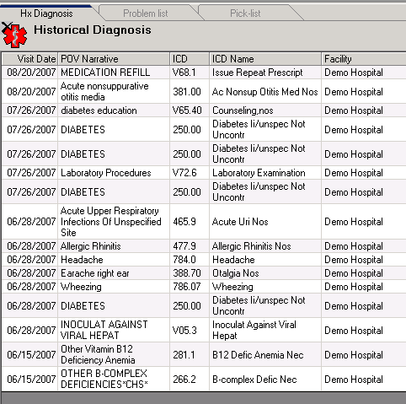

PRC Procedure Configuration ...

CNF Suppress Confirmatory E&M Codes (bgo e&m suppress confirmation)
I did not work when I edited that parameter.

CPT Disable CPT Code Editing (bgo disable cpt editing)
This parameter disables editing or entries in services tab.

Before editing parameter. Notice I have ability to add CPT’s from historical services.
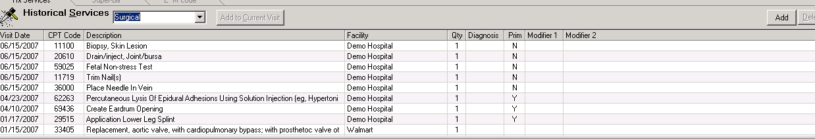

DEMO HOSPITAL RPMS-EHR Management Version 1.1
Disable CPT Code Editing

Disable CPT Code Editing may be set for the following:

100 User USR [choose from NEW PERSON]
200 Class CLS [choose from USR CLASS]

Enter selection: 100 User NEW PERSON
Select NEW PERSON NAME: USER,BSTUDENT

--------- Setting Disable CPT Code Editing for User: USER,BSTUDENT ---------
Value: y YES

Now I can’t use superbill or historical services tab to enter my CPT’s. I can still however enter CPT code thru the visit services tab.
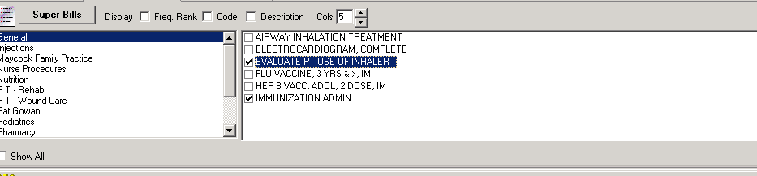
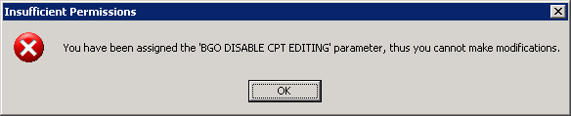

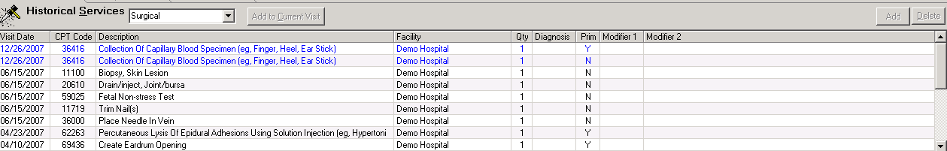

EAM Disable Evaluation & Management Editing (bgo disable e&m editing)
This parameter disables editing or entering of E&M codes

Before changing this parameter:
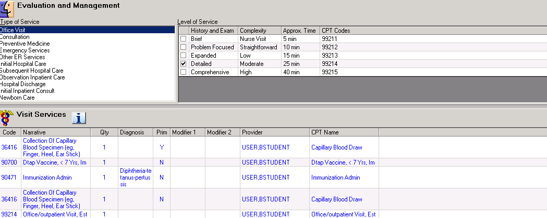

DEMO HOSPITAL RPMS-EHR Management Version 1.1
Disable Evaluation & Management Editing

Disable Evaluation & Management Editing may be set for the following:

100 User USR [choose from NEW PERSON]
200 Class CLS [choose from USR CLASS]

Enter selection: 100 User NEW PERSON
Select NEW PERSON NAME: USER,BSTUDENT

-- Setting Disable Evaluation & Management Editing for User: USER,BSTUDENT --
Value: YES

I still can see the E&M code tab, but when I try the click on one of the codes, nothing happens.

ERC Suppress Emergency Room E&M Codes (bgo e&m suppress ER codes)
This parameter takes out the Emergency services E&M codes. I could not make it work for EHR v1.1. But in EHR v1.1 patch 1 this works.

Before editing this parameter
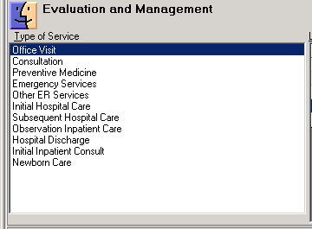

DEMO HOSPITAL RPMS-EHR Management Version 1.1
Suppress Emergency Room E&M Codes

Suppress Emergency Room E&M Codes may be set for the following:

10 User USR [choose from NEW PERSON]
20 Class CLS [choose from USR CLASS]
80 Division DIV [choose from INSTITUTION]
90 Package PKG [BGO COMPONENTS]

Enter selection: 10 User NEW PERSON
Select NEW PERSON NAME: USER,BSTUDENT

----- Setting Suppress Emergency Room E&M Codes for User: USER,BSTUDENT -----
Value: YES After editing field
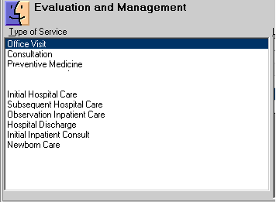

HOS Suppress Hospital E&M Codes (bgo e&m suppress hosp code)
Parameter suppress the Hospital codes from populating your E&M tab.

Before editing the field
DEMO HOSPITAL RPMS-EHR Management Version 1.1
Suppress Hospital E&M Codes

Suppress Hospital E&M Codes may be set for the following:

10 User USR [choose from NEW PERSON]
20 Class CLS [choose from USR CLASS]
80 Division DIV [choose from INSTITUTION]
90 Package PKG [BGO COMPONENTS]

Enter selection: 10 User NEW PERSON
Select NEW PERSON NAME: USER,BSTUDENT

-------- Setting Suppress Hospital E&M Codes for User: USER,BSTUDENT --------
Value: YES

After editing the field.
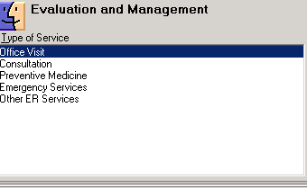

ICD Enable Support for ICD Procedure Entry (bgo enable IDC procedure entry) Enable using ICD 0 codes

REM Reminder Configuration ...
This menu is where you find everything you need to configure your reminders.
CFM Reminder Computed Finding Management ...
This is where you will find your computed findings for your reminders
DEF Reminder Definition Management ...
This menu contain all your reminder definitions
DLG Reminder Dialog Management ...
This menu is where you create and edit your reminder dialogs
EXC Reminder Exchange
This menu is where you load or export your reminder dialogs
INF Reminder Information Only Menu ...
This menu contains all your reminder information.
PAR Reminder Parameters ...
This menu is where you will edit your reminder parameters to activate the system
RPT Reminder Reports ...
This menu runs reminder reports
SPO Reminder Sponsor Management ...
This menu contains a list of reminder sponsors, you can create your own sponsor. You can not edit national one.
TAX Reminder Taxonomy Management ...
This menu is where you create and edit taxonomies (set of codes)used for your reminders
TRM Reminder Term Management ...
This menu is where you create and edit your reminder terms (labs, exams etc) used for your reminders
TST Reminder Test
This menu test your reminder. You need to pick patients that will turn the reminder on, turn if off and ones that this reminder would not apply to.

RPT Report Configuration ...
FMT Print Formats
This option is where you would create your print formats. You then can use these print formats to create your print outs for orders or reports.

HSM Health Summary Configuration ...(ORWRP HEALTH SUMMARY LIST ALL)
ALL List All Health Summaries
DESCRIPTION: Set to YES to list all health summaries. Set to NO to list only those health summaries specified in the ORWRPBHS HEALTH SUMMARY LIST and ORWRP HEALTH SUMMARY TYPE LIST parameters. Very important do not set this one if you set the other reports in the parameters above.

IHS IHS Health Summary Configuration ...
DESCRIPTION: Submenu for health summary maintenance functions:
Create your IHS health summaries here.

DF Delete Health Summary Flowsheet
DI Delete Health Summary Flowsheet Item
DM Delete Measurement Panel Definition
DS Delete Health Summary Type
FMMT Create/Modify Health Summary Type using Fileman
HM Health Maintenance Reminders ...
HS Generate Health Summary
HSSP Update Health Summary Site Parameters
IS Inquire About a Health Summary Type
LC List Health Summary Components
LF List Health Summary Flowsheets
LI List Health Summary Flowsheet Items
LM List Measurement Panel Types
LS List Health Summary Types
MF Create/Modify Flowsheet
MI Create/Modify Flowsheet Item
MM Create/Modify Measurement Panel
MS Create/Modify Health Summary Type
PP Print Health Maintenance Item Protocols
TYP IHS Health Summary Types (orwrpbhs health summary list)
This is the parameter you will add your IHS health summaries by sequence

VHA VHA Health Summary Configuration ...
DESCRIPTION: This option is used by individuals who have the capability to build their own Health Summary Types. It has all of the capabilities of the 'Health Summary Users Menu' with the addition of the 'Build Health Summary Type Menu' and the option to set parameters for nightly batch printing of Health Summaries by Location. You need the GMTSMGR Key in order to edit a VA health summary.

BAT List Batch Health Summary Locations
BLD Build Health Summary Type Menu ...
DEF Display/Edit Health Summary Site Defaults ...
LOC Setup Batch Print Locations
MNT Health Summary Maintenance Menu ...
PRN Print Health Summary Menu ...
TYP VHA Health Summary Types Menu ... (orwrp health summary type)
This is the parameter that you will add your VHA HS by sequence

PAR Report Parameters ...
ALL Default Time and Occurrence Limits for All Reports (orwrp time/occ limits all)
This parameter sets a default for all reports found on the Reports Tab in CPRS. Individual values of this parameter, for each report can be set by editing the parameter ORWRP TIME/OCC LIMITS ALL.
How it works:
DEMO HOSPITAL RPMS-EHR Management Version 1.1
Default Time and Occurrence Limits for All Reports

Default time/occ for all reports may be set for the following:

1 User USR [choose from NEW PERSON]
4 Division DIV [choose from INSTITUTION]
6 System SYS [DEMO-HO.IHS.GOV]
9 Package PKG [ORDER ENTRY/RESULTS REPORTING]
Enter selection: 9 Package ORDER ENTRY/RESULTS REPORTING

Parameters set for 'Package' may be replaced if ORDER ENTRY/RESULTS REPORTING
is installed in this account.

Setting Default time/occ for all reports for Package: ORDER ENTRY/RESULTS REPORTING

Time & Occurrence limits for all: T-7;T;10// ?

Format: Start Date;End Date;Occurrence limit (T-100;T;200).
RPT Default Time and Occurrence Limits by Report (orwrp time/occ limits indv)
This parameter sets the default time and occurrence limits for reports found on the Reports Tab in CPRS.
Default Time and Occurrence Limits by Report

Report time & occurrence limits may be set for the following:

1 User USR [choose from NEW PERSON]
6 System SYS [DEMO-HO.IHS.GOV]
9 Package PKG [ORDER ENTRY/RESULTS REPORTING]

Enter selection: 9 Package ORDER ENTRY/RESULTS REPORTING

Parameters set for 'Package' may be replaced if ORDER ENTRY/RESULTS REPORTING
is installed in this account.

Setting Report time & occurrence limits for Package: ORDER ENTRY/RESULTS REPOR
TING
Adding a different range for ORRPW ADT DEMOG

Report: ORRPW ADT DEMOG// ORRPW ADT DEMOG Demographics Demographics
ORRPW ADT DEMOG
Time & Occurrence Limits : ??
Format: Start date;End date;Occurrence limit (T-100;T;100).

Time & Occurrence Limits : T-90;T;20

This is what I have in the system.
Report Value
------ -----
ORRP HEALTH SUMMARY T-7;T;10
ORRPW ADT DEMOG T-90;T;20
SYS System Display Parameters (orwrp report list)
This is the old ORWRP REPORT LIST parameter. Add your reports that you would like to display in your GUI here.

DEMO HOSPITAL RPMS-EHR Management Version 1.1
System Display Parameters

GUI Reports - System for System: DEMO-HO.IHS.GOV
------------------------------------------------------------------------------
List of reports 1 ORRP IMAGING
2 ORRPW REPORT CATEGORIES
3 ORRP HEALTH SUMMARY
4 ORRP LAB STATUS
5 ORRP AP MENU
6 ORRP DIETETICS PROFILE
7 ORRP NUTRITIONAL ASSESS
8 ORRP VITALS CUM
9 ORRP DAILY ORDER SUMMARY
10 ORRP ORDER SUM FOR A DATE RNG
11 ORRP CHART COPY SUMMARY
12 ORRP OUTPATIENT RX PROFILE
List of lab reports
------------------------------------------------------------------------------
------------ Setting List of reports for System: DEMO-HO.IHS.GOV ------------
Select Sequence:

Notice the above sequence matches the report available in GUI
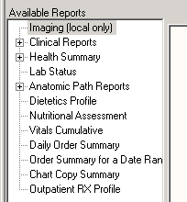

USR User Display Parameters
Same parameter above but you can set it by users.
DEMO HOSPITAL RPMS-EHR Management Version 1.1
User Display Parameters
Select NEW PERSON NAME: USER,DSTUDENT

GUI Reports - User for User: USER,DSTUDENT
------------------------------------------------------------------------------
List of reports
List of lab reports

SPL Spellchecking Configuration ...
ENA Enable Spellchecking Service (behosp enable spellchecker)
Enable spellchecking service. If set to YES, the spellchecking service is enabled. If NO, it is disabled. Note that the spellchecking service may require additional software to
be installed on the workstation (e.g., MS Word). If these additional requirements are not met, the service will not be enabled regardless of this setting.

DEMO HOSPITAL RPMS-EHR Management Version 1.1
Enable Spellchecking Service

Enable Spellchecker Service may be set for the following:

100 User USR [choose from NEW PERSON]
500 Division DIV [choose from INSTITUTION]
900 System SYS [DEMO-HO.IHS.GOV]

Enter selection: 900 System DEMO-HO.IHS.GOV

------ Setting Enable Spellchecker Service for System: DEMO-HO.IHS.GOV ------
Enable spellchecking service?: YES// ?

Enter YES to enable the spellchecking service.

PLG Spellchecking Service Plugin (behosp service plug in)
I would not edit this parameter. Accept what is set in package.

Spellchecking Service Plugin

Spellchecker Service Plugin may be set for the following:

100 User USR [choose from NEW PERSON]
500 Division DIV [choose from INSTITUTION]
900 System SYS [DEMO-HO.IHS.GOV]

Enter selection: 900 System DEMO-HO.IHS.GOV

------ Setting Spellchecker Service Plugin for System: DEMO-HO.IHS.GOV ------
Spellchecker service plugin: BEHSPELLCHECK.SPELLCHECK// ??
Choose from:
BEHSPELLCHECK.SPELLCHECK
TIU TIU Configuration ...
CLN TIU Menu for Clinicians ...
DESCRIPTION: Main Menu used by clinicians to create, edit, sign and read TIU documents. Sub-menu below.
HLP TIU Help for Clinicians ...
IPD Individual Patient's Documents
MPD Multiple Patient Documents
MYU All MY UNSIGNED Documents
SPT Search by Patient AND Title
TRM TIU Reports Menu ...

HIS TIU Menu for Medical Records ..
DESCRIPTION: Combined medical records menu and application coordinator menu. Sub-menus below
HIMS Special HIMS TIU Reports ... (BTIU SPECIAL REPORTS)

Select TIU Menu for Medical Records Option: hims Special HIMS TIU Reports

- Missing Text Report

This patch contains a routine used for the reporting of TIU documents that do not have any report text, are missing the 0 node of the text node, or both. The report results have the following categories:
1. Missing Text Only–The note has a 0 TEXT node, but no text (this can be acceptable depending on the status of the document, such as Undictated).
2. Missing 0 Node Only–The note has text, but no 0 TEXT node.
3. Missing 0 node & Text–The note does not have a 0 TEXT node or text.

A new menu has been added to BTIU MENU2–TIU Menu for Medical Records, as follows:

Select Special HIMS TIU Reports Option: 1
START WITH REFERENCE DATE: Jan 01, 2003// (JAN 01, 2003)
GO TO REFERENCE DATE: Mar 12, 2013// (MAR 12, 2013)

Would you like a delimited report? NO//

DEVICE: HOME// VT

Searching...

Date range searched: Jan 01, 2003 - Mar 12, 2013
# of Records:
Searched 531
Missing Text Only 0
Missing 0 Node Only 1
Missing 0 node & Text 1
---
Total 2

Elapsed Time: 0 minute(s) 0 second(s)
Current User: USER,BSTUDENT
Current Date: Mar 12, 2013@10:20:33

Doc # Entry Date/Time Title
Missing Reference Date/Time Patient
Status Signature Date/Time Author/Dictator
------ ------------------- ---------------
49 May 18, 2006@11:06:49 WATERHOUSE ENCOUNTER NOTES
0 Node May 18, 2006@11:06 HENRY,BETTY SUE(115866)
COMPLETED May 18, 2006@13:52:55 USER,SSTUDENT

68 May 18, 2006@15:28:13 DIABETES CONSULT
0/Text May 18, 2006@15:28 JONES,TYRA(146772)
COMPLETED May 22, 2012@14:57:24 USER,DSTUDENT

2 Missing Text Cleanup

START WITH REFERENCE DATE: Jan 01, 2003// (JAN 01, 2003)
GO TO REFERENCE DATE: Mar 12, 2013// (MAR 12, 2013)

Requested Start Time: NOW// (MAR 12, 2013@10:29:42)

Your task # is: 402771

When the task is completed, you will get a notification in the VA Alert,

1.I TIUPS177 has finished.
2.I TIUPS177 has finished.
3.I TIUPS174 has finished.

The notification reads as follow
or RETURN to continue: 1
Processed Alert Number 1
TIUPS177 has finished.
Continue (Y/N) or F(orward) or R(enew) YES//

- Reassignment Document Report
TIU has an option that enables you to reassign a document. This patch provides a routine used for the reporting of those documents that have been reassigned based on the date range specified. This report has been added to the same new HIMS Special Reports menu, as follows:

The following is a sample Reassignment Report:
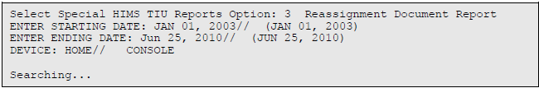

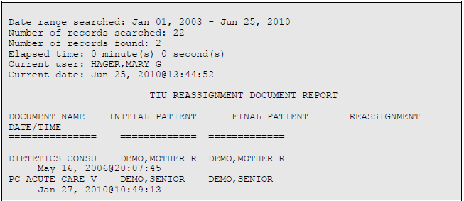

IPD Individual Patient Document
DESCRIPTION: Option to view patient's document. To be used by medical records staff only.

LAD List of Active Document Titles
DESCRIPTION: Displays a list of active titles sorted by document class.

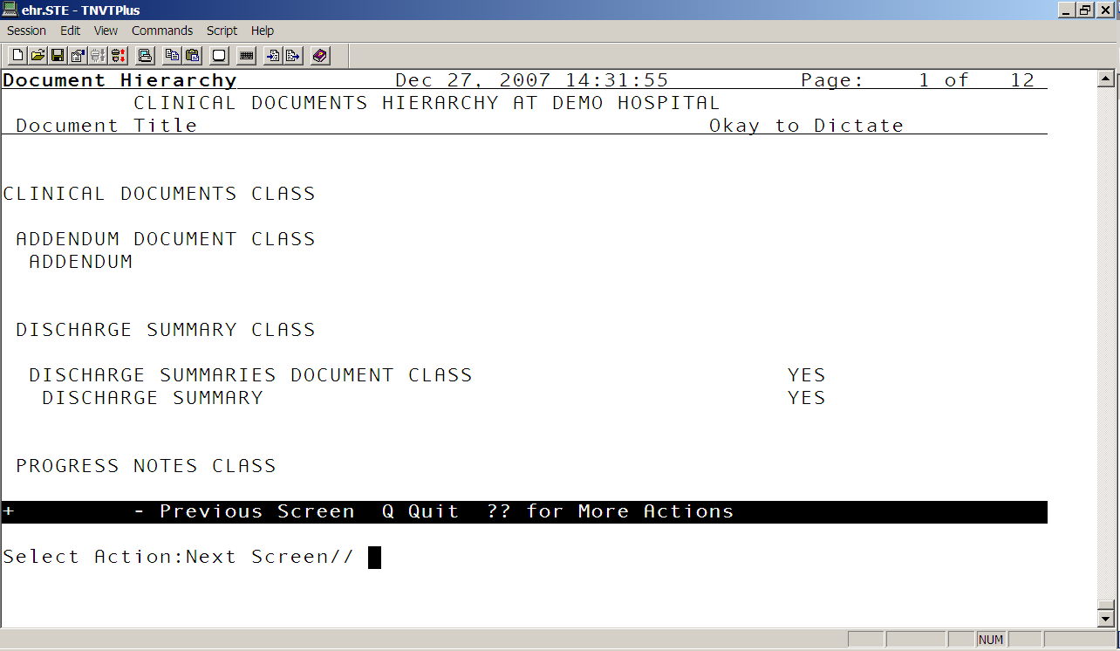

MPD Multiple Patient Documents
DESCRIPTION: IHS version of report to view documents from multiple patients.

Select TIU Menu for Medical Records Option: Multiple Patient Documents

Select Status: UNVERIFIED// completed

Select CLINICAL DOCUMENTS Type(s): Progress Notes// Progress Notes
Start Entry Date [Time]: T-7// t-30 (NOV 27, 2007)
Ending Entry Date [Time]: NOW//

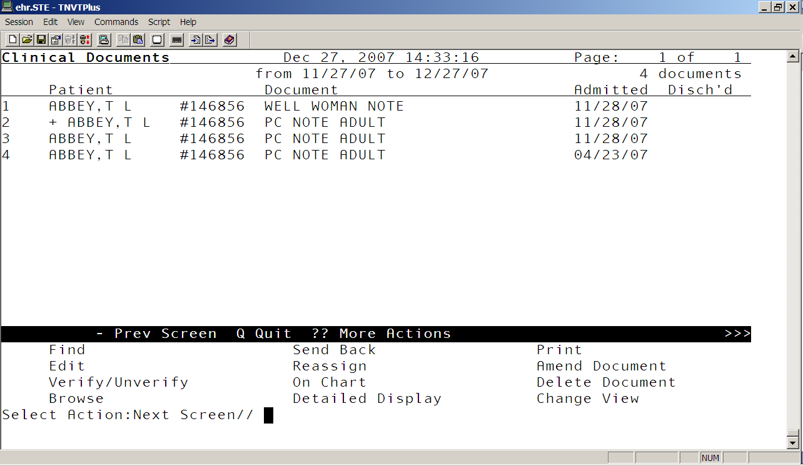

PDM Print Documents Menu ...
DESCRIPTION: This menu allows medical records personnel access to options which print CHART or WORK copies of Discharge Summaries, Progress Notes, or mixed Documents on demand.

SIG Awaiting Signature Listing
DESCRIPTION: Use this option to pull a list of charts in the Incomplete
Chart system that are waiting for signatures on TIU documents. You can update the Incomplete Chart file here and print out a chart copy of the document.

SSD Search for Selected Documents
DESCRIPTION: Allows Medical Records staff to generate a list of selected documents based on extended search criteria (i.e., STATUS, SEARCH CATEGORY, and REFERENCE DATE RANGE).

STR Statistical Reports ...
DESCRIPTION: IHS version of Statistical Reports Menu. Contains IHS option and header code.

TMM TIU Maintenance Menu ...
DESCRIPTION: This menu contains all parameter, docuement setup and user class options used by the TIU application coordinator

DDM Document Definitions (Manager) ...
DESCRIPTION: Document Definition menu for Application Coordinators/IRM. Lets you create new entries, delete appropriate entries, copy entries, and edit entries, including Technical M fields and Upload fields. Editing Exception: National Standard entries cannot be edited/deleted on ANY menu. The Manager menu overrides Ownership for editing, but not for deleting entries; a manager can edit any entry regardless of owner, but must own an entry in order to delete it.

TAT TIU Alert Tools
You can search for documents in this menu

TPM TIU Parameters Menu ...
DESCRIPTION: This option allows the Clinical Coordinator or IRM Application Specialist to set up either the Basic or Upload Parameters for Text Integration Utilities (TIU).

TPM1 Basic TIU Parameters
DESCRIPTION: This option allows the user to enter the basic, or general parameters which govern the behavior of the Text Integration Utilities.

TPM2 Modify Upload Parameters
DESCRIPTION: This option allows the definition and modification of parameters for the batch upload of documents into DHCP.

TPM3 Document Parameter Edit
DESCRIPTION: This option allows the user to enter the parameters which apply to specific documents (i.e., Titles), or groups of documents (i.e., Classes, or Document Classes).

TPM4 Progress Notes Batch Print Locations
DESCRIPTION: Option for entering hospital locations used for [TIU PRINT PN OUTPT LOC] and [TIU PRINT PN WARD] options. If locations are not entered in this file they will not be selectable from these options.

TPM5 Division - Progress Notes Print Params
DESCRIPTION: These parameters are used by the [TIU PRINT PN BATCH INTERACTIVE] and [TIU PRINT PN BATCH SCHEDULED] options. If the site wants a
header other than what is returned by $$SITE^VASITE, the .02 field of the 1st entry in this file will be used. For example, Waco-Temple-Marlin can have the institution of their progress notes as 'CENTRAL TEXAS HCF.'

UCM User Class Management Menu ...
DESCRIPTION: This is the menu of options for management of User Class Definition and Membership as well as management of Business Rules.

UNS Unsigned/Uncosigned Report
Select TIU Menu for Medical Records Option: uns Unsigned/Uncosigned Report
Select division: CIHA HOSPITAL// 7247
Select another division:

Please specify an Entry Date Range:

Start Entry Date: t-90 (DEC 12, 2012)
Ending Entry Date: t (MAR 12, 2013)

Select service: ALL//

Type
Select one of the following:

F FULL
S SUMMARY

Type of Report: s SUMMARY

DEVICE: HOME// VT
Unsigned and Uncosigned Documents Dec 12, 2012 thru Ma
r 12, 2013@23:59:59 Page 1
PRINTED: for DEMO HOSPITAL
MAR 12, 2013@10:53
------------------------------------------------------------------------------

Totals for Service: AMBULATORY CARE--- UNSIGNED: 5 UNCOSIGNED: 0

Totals for Service: OUTPATIENT NURSING--- UNSIGNED: 7 UNCOSIGNED: 1

Totals for Division: DEMO HOSPITAL--- UNSIGNED: 12 UNCOSIGNED: 1

Example full report:

Unsigned and Uncosigned Documents Dec 12, 2012 thru M1
PRINTED: for DEMO HOSPITAL
MAR 12, 2013@10:54
--------------------------------------------------------------------------------
AUTHOR PATIENT LAST4 STATUS ENTRY DATE IEN N
--------------------------------------------------------------------------------

SERVICE: AMBULATORY CARE
USER, C ABBOTT,CHARLES 7496 UNSIGNED 2/27/13@10:06:26 582
USER, E ABBEY,TRESSIA L 8464 UNSIGNED 3/5/13@13:13:05 587
USER, H ABBOTT,CHARLES 7496 UNSIGNED 12/17/12@11:12:40 565
USER, H ABBOTT,RAY MITC 0978 UNSIGNED 12/19/12@13:02:45 572
USER, M ABERNATHY,ALICE 4543 UNSIGNED 2/21/13@15:50:46 581

Totals for Service: AMBULATORY CARE--- UNSIGNED: 5 UNCOSIGNED: 0

SERVICE: OUTPATIENT NURSING
USER, B BOUNDS,ORION DE 5121 UNCOSIGNED 12/17/12@13:51:31 566
USER, B ABBOTT,CHARLES 7496 UNSIGNED 12/17/12@16:29:15 569
USER, B ABBOTT,CHARLES 7496 UNSIGNED 12/17/12@16:33:40 570
USER, B ABBEY,TRESSIA L 8464 UNSIGNED 12/17/12@16:38:22 571
USER, B ABBEY,TRESSIA L 8464 UNSIGNED 1/17/13@16:10:14 577
USER, B ABBOTT,CHARLES 7496 UNSIGNED 1/17/13@16:15:42 579
USER, B WILCOX,JANICE S 3578 UNSIGNED 3/4/13@10:11:27 584
USER, B WILCOX,JANICE S 3578 UNSIGNED 3/4/13@10:25:47 586

Totals for Service: OUTPATIENT NURSING--- UNSIGNED: 7 UNCOSIGNED: 1

Totals for Division: DEMO HOSPITAL--- UNSIGNED: 12 UNCOSIGNED: 1

GRAND Totals (All Divisions)--- UNSIGNED: 12 UNCOSIGNED: 1

UPL TIU Upload Menu ...
DESCRIPTION: This menu includes options to upload batches of documents, and to obtain help on the header formats for the various documents which have been defined for upload by your site.

VUA View a User's Alerts
DESCRIPTION: Displays a user's alert list. Used to compare alert list with MYU list which medical records personnel can see via SSD option.

PAR TIU Parameters ...
AUT Note Autosave Interval (ORWOR AUTOSAVE NOTE)
DESCRIPTION: This parameter determines how many seconds should elapse between each auto-save of a note that is being edited in the graphical interface.

CLN Auto Cleanup Upon User Termination (TIU TEMPLATE USER AUTO DELETE)
This parameter is queried by code which activates upon termination of a
user. It the parameter is set to 'Y' then whenever a user is terminated,
his/her non-shared TIU templates will be deleted. The default setting is
'N.'

DEMO HOSPITAL RPMS-EHR Management Version 1.1
Auto Cleanup Upon User Termination

Y/N auto cleanup upon termination may be set for the following:

1 Division DIV [choose from INSTITUTION]
2 System SYS [DEMO-HO.IHS.GOV]
3 Package PKG [TEXT INTEGRATION UTILITIES]

Enter selection: 3 Package TEXT INTEGRATION UTILITIES

Parameters set for 'Package' may be replaced if TEXT INTEGRATION UTILITIES
is installed in this account.

Setting Y/N auto cleanup upon termination for Package: TEXT INTEGRATION UTILIT
IES
Value: ?

Enter Y or N; Y turns auto-template cleanup on.

CLS Personal Template Access by User Class (TIU PERSONAL TEMPLATE ACCESS)
This parameter is used to specify access to personal templates for a
specific user class. A setting of READ ONLY allows the use of personal
templates, but does not allow the creation of new personal templates.
To restrict template use by USER, DIVISION or SYSTEM, use the
TIU PERSONAL TEMPLATE ACCESS parameter. These two parameters work together, in the following precedence order:

Precedence Parameter
---------- ----------------------------
USER TIU PERSONAL TEMPLATE ACCESS
USER CLASS TIU TEMPLATE ACCESS BY CLASS
LOCATION TIU PERSONAL TEMPLATE ACCESS
SERVICE TIU PERSONAL TEMPLATE ACCESS
DIVISION TIU PERSONAL TEMPLATE ACCESS
SYSTEM TIU PERSONAL TEMPLATE ACCESS

DEMO HOSPITAL RPMS-EHR Management Version 1.1
Personal Template Access by User Class

Setting Personal Template Access by User Class for System: DEMO-HO.IHS.GOV
Select User Class: pro
1 PROCTOLOGIST
2 PROSTHETICS CLERK
3 PROVIDER
CHOOSE 1-3: 3 PROVIDER
Are you adding PROVIDER as a new User Class? Yes// YES

User Class: PROVIDER// PROVIDER PROVIDER
Value: ?

READ ONLY allows use, but not creation of, personal templates.

Select one of the following:

0 FULL ACCESS
1 READ ONLY
2 NO ACCESS

DEF Default Template for Document Type (TIU DEFAULT TEMPLATES)
I could not figure out what this does. It s a free text field.

Default Template for Document Type
Select NEW PERSON NAME: MOSELY,ELVIRA

-- Setting Default Template Notes/Consults/DC Summ for User: MOSELY,ELVIRA --
DEFAULT TEMPLATES: notes// ??

Default Template for Notes;Consults;DC Summ tabs

DEFAULT TEMPLATES: notes// ?

This response can be free text.

FLD Template Field Editor User Classes (TIU FIELD EDITOR CLASSES)
This parameter contains a list of ASU user classes who's
members are allowed to edit template fields.

Template Field Editor User Classes

Template Field Editor User Classes may be set for the following:

1 User USR [choose from NEW PERSON]
3 Service SRV [choose from SERVICE/SECTION]
4 Division DIV [choose from INSTITUTION]
5 System SYS [DEMO-HO.IHS.GOV]
6 Package PKG [TEXT INTEGRATION UTILITIES]

Enter selection: 5 System DEMO-HO.IHS.GOV

-- Setting Template Field Editor User Classes for System: DEMO-HO.IHS.GOV --
Select Sequence Number: ?

Sequence Number Value
--------------- -----
- CLINICAL COORDINATOR

OBJ Allowed Personal Template Objects (TIU TEMPLATE PERSONAL OBJECTS)
Contains TIU Objects that are allowed in the Insert Patient Data Object
dialog of the Templates Editor, when adding objects to personal
templates. This parameter is cummulative at all levels. If no objects
are entered in this parameter, all objects will be allowed.

PER Personal Template Access (TIU TEMPLATE ACCESS BY CLASS)
This parameter is used to specify access to personal templates. A setting
of READ ONLY allows the use of personal templates, but does not allow the creation of new personal templates. To restrict template use by USER CLASS, use the TIU TEMPLATE ACCESS BY CLASS parameter. These two parameters work together, in the following precedence order:

Precedence Parameter
---------- ----------------------------
USER TIU PERSONAL TEMPLATE ACCESS
USER CLASS TIU TEMPLATE ACCESS BY CLASS
LOCATION TIU PERSONAL TEMPLATE ACCESS
SERVICE TIU PERSONAL TEMPLATE ACCESS
DIVISION TIU PERSONAL TEMPLATE ACCESS
SYSTEM TIU PERSONAL TEMPLATE ACCESS

DEMO HOSPITAL RPMS-EHR Management Version 1.1
Personal Template Access
Personal Template Access may be set for the following:

1 User USR [choose from NEW PERSON]
2 Location LOC [choose from HOSPITAL LOCATION]
3 Service SRV [choose from SERVICE/SECTION]
4 Division DIV [choose from INSTITUTION]
5 System SYS [DEMO-HO.IHS.GOV]

Enter selection: 5 System DEMO-HO.IHS.GOV

------- Setting Personal Template Access for System: DEMO-HO.IHS.GOV -------
PERSONAL TEMPLATE ACCESS: FULL ACCESS// ?

READ ONLY allows use, but not creation of, personal templates.

Select one of the following:

0 FULL ACCESS
1 READ ONLY
2 NO ACCESS

REM Reminder Dialogs Allowed as Templates (TIU TEMPLATE REMINDER DIALOGS)
Contains Reminder Dialogs that are allowed to be used as TIU Templates.
This parameter is different than most others in that each level is
cumulative, so all Reminder Dialogs at the System, Division, Service
and User levels can be used in Templates.

Display Sequence Value
---------------- -----
1 FDIH DIABETES EDUCATION
2 CCL-ACC
3 IHS-TEST
4 VITAMIN B12 DIALOGUE
5 TIU DEPO PROVERA
6 DIABETIC FOOT EXAM
7 MAMMOGRAM
8 MAMMOGRAM FIGURES 2
9 ALCOHOL SCREEN
10 ADULT IMMUNIZATION

VER Verify Note Title (ORWOR VERIFY NOTE TITLE)
If this parameter is set to YES, the window that allows the user to change
a note title will appear whenever the user starts to enter a new note,
even if they have a default title. If the parameter is set to NO, -and-
the user has a default title, that title will be automatically loaded when
a new note is entered.

VIT Vital Measurement Configuration ...
CVR Measurements Listed on Cover Sheet (behovm vital list)
Lists which vitals appear on the cover sheet and in which order. This is the list providers will see.

DEMO HOSPITAL RPMS-EHR Management Version 1.1
Measurements Listed on Cover Sheet

Vital signs list for cover sheet may be set for the following:

100 User USR [choose from NEW PERSON]
200 Class CLS [choose from USR CLASS]
300 Service SRV [choose from SERVICE/SECTION]
400 Location LOC [choose from HOSPITAL LOCATION]
500 Division DIV [choose from INSTITUTION]
900 System SYS [DEMO-HO.IHS.GOV]

Enter selection: 900 System DEMO-HO.IHS.GOV

--- Setting Vital signs list for cover sheet for System: DEMO-HO.IHS.GOV ---
Select Sequence: ?

Sequence Value
-------- -----
10 TEMPERATURE
20 PULSE
30 RESPIRATIONS
40 BLOOD PRESSURE
50 HEIGHT
60 WEIGHT
70 PAIN
80 HEAD CIRCUMFERENCE
90 BODY MASS INDEX
100 B.M.I. PERCENTILE

GUI
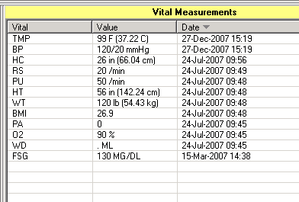

DVE Disable Triage Vitals Editing (bgo disable vital editing)
This parameter has been disable.

OVR Override Default Units (behovm default units)
This allows the CAC to set some vitals in metric and others in US measurements when entering vital signs. Permits overriding the default units for any measurement type.

DEMO HOSPITAL RPMS-EHR Management Version 1.1
Override Default Units

Default units for measurement may be set for the following:

100 User USR [choose from NEW PERSON]
200 Class CLS [choose from USR CLASS]
300 Service SRV [choose from SERVICE/SECTION]
400 Location LOC [choose from HOSPITAL LOCATION]
500 Division DIV [choose from INSTITUTION]
900 System SYS [DEMO-HO.IHS.GOV]

Enter selection: 900 System DEMO-HO.IHS.GOV

----- Setting Default units for measurement for System: DEMO-HO.IHS.GOV -----
Select Measurement Type: hc
Are you adding HEAD CIRCUMFERENCE as a new Measurement Type? Yes// YES

Measurement Type: HEAD CIRCUMFERENCE// HEAD CIRCUMFERENCE HEAD CIRCUMFERENCE
Default Units: METRIC

PER Data Entry Permissions (behovm data entry)
If yes, the user is permitted to enter vital measurement data.
Data Entry Permissions
Can enter vital measurements? may be set for the following:

100 User USR [choose from NEW PERSON]
200 Class CLS [choose from USR CLASS]
300 Service SRV [choose from SERVICE/SECTION]
400 Location LOC [choose from HOSPITAL LOCATION]
500 Division DIV [choose from INSTITUTION]
900 System SYS [DEMO-HO.IHS.GOV]

Enter selection: 900 System DEMO-HO.IHS.GOV

----- Setting Can enter vital measurements? for System: DEMO-HO.IHS.GOV -----
Can enter vital measurements?: YES// ??

If yes, the user is permitted to enter vital measurement data.

Can enter vital measurements?: YES//

TPL Data Entry Templates (behovm template)
Controls the formatting of the vital measurement data entry dialog.

DEMO HOSPITAL RPMS-EHR Management Version 1.1
Data Entry Templates

Vital Measurement Input Template may be set for the following:

100 User USR [choose from NEW PERSON]
200 Class CLS [choose from USR CLASS]
300 Service SRV [choose from SERVICE/SECTION]
400 Location LOC [choose from HOSPITAL LOCATION]
500 Division DIV [choose from INSTITUTION]
900 System SYS [DEMO-HO.IHS.GOV]

Enter selection: 900 System DEMO-HO.IHS.GOV

--- Setting Vital Measurement Input Template for System: DEMO-HO.IHS.GOV ---
Select Sequence: ?

Sequence Value
-------- -----
10 TEMPERATURE
20 PULSE
30 RESPIRATIONS
40 BLOOD PRESSURE
50 HEIGHT
60 WEIGHT
70 PAIN

GUI
