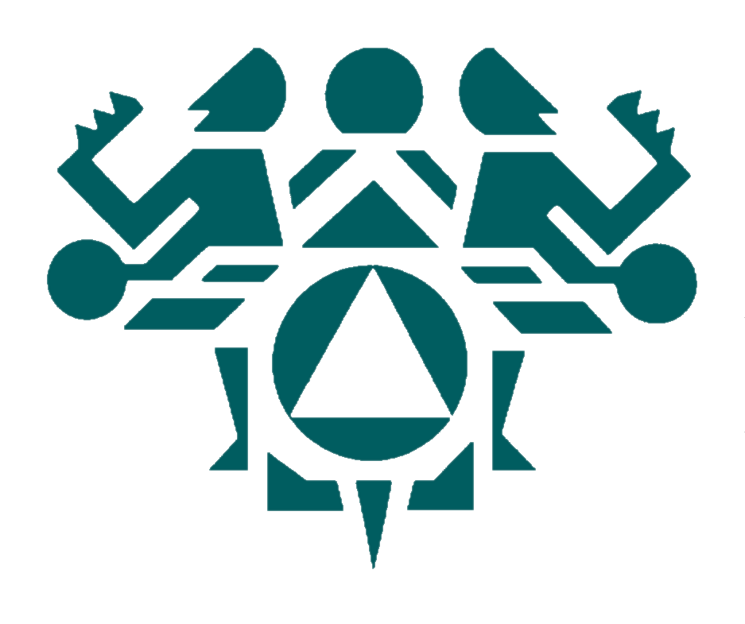

NORTHWEST
PORTLAND
AREA
INDIAN
HEALTH
BOARD

Burns –Paiute Tribe
Chehalis Tribe
Coeur d’Alene Tribe
Colville Tribe
Coos, Suislaw &
Lower Umpqua Tribe
Coquille Tribe
Cow Creek Tribe
Cowlitz Tribe
Grand Ronde Tribe
Hoh Tribe
Jamestown S’Klallam Tribe
Kalispel Tribe
Klamath Tribe
Kootenai Tribe
Lower Elwha Tribe
Lummi Tribe
Makah Tribe
Muckleshoot Tribe
Nez Perce Tribe
Nisqually Tribe
Nooksack Tribe
NW Band of Shoshoni Tribe
Port Gamble S’Klallam Tribe
Puyallup Tribe
Quileute Tribe
Quinault Tribe
Samish Indian Nation
Sauk-Suiattle Tribe
Shoalwater Bay Tribe
Shoshone-Bannock Tribe
Siletz Tribe
Skokomish Tribe
Snoqualmie Tribe
Spokane Tribe
Squaxin Island Tribe
Stillaguamish Tribe
Suquamish Tribe
Swinomish Tribe
Tulalip Tribe
Umatilla Tribe
Upper Skagit Tribe
Warm Springs Tribe
Yakama Nation

2121 SW Broadway
Suite 300
Portland, OR 97201
Phone: (503) 228-4185
Fax: (503) 228-8182
www.npaihb.org

RESOLUTION # 19-02-03

FORMAL RECOGNITION OF TRIBAL YOUTH DELEGATE PROGRAM

WHEREAS, the Northwest Portland Area Indian Health Board (hereinafter “NPAIHB” or the “Board”) was established in 1972 to assist Tribal governments to improve the health status and quality of life of Indian people; and

WHEREAS, the Northwest Portland Area Indian Health Board is a “tribal organization” as defined by the Indian Self-Determination and Education Assistance Act (P.L. 93-638 seq. et al) that represents forty-three federally recognized tribes in the states of Idaho, Oregon, and Washington (“member tribes”; and

WHEREAS, in accordance with the definitions of the Indian Self-Determination and Education Assistance Act at 25 USCS § 450b, a tribal organization is recognized as a governing body of any Indian tribe and includes any legally established organization of Indians which is controlled, sanctioned, or chartered by such governing body or which is democratically elected by the adult members of the Indian community to be served by such organization and which includes the maximum participation of Indians in all phases of its activities; and

WHEREAS, the NPAIHB is dedicated to assisting and promoting the health needs and concerns of Indian people; and

WHEREAS, the primary goal of the NPAIHB is to improve the health and quality of life of its member tribes; and

WHEREAS, developing leadership skills of our younger populations will provide the opportunity to improve health services and policy in a more inclusive and diverse manner; and

WHEREAS, opportunities for youth to learn about health careers, governance structures, and policy will long term positive effects for Indian communities; and

WHEREAS, engaging our youth in the development of approaches to wellness and solutions to their health issues is more likely to ensure their participation and have better outcomes.

NOW THEREFORE BE IT RESOLVED that the Northwest Portland Area Indian Health Board recognizes the Tribal Youth Delegate program as the official youth policy body for the Board and its member tribes; and

BE IT FURTHER RESOLVED, the Northwest Portland Area Indian Health Board encourages our member tribes to recruit Tribal Youth Delegates to represent their communities to expand involvement of youth in policy development and in setting priorities that address the issues important to their youth populations.

