Resolution # 19-04-14

Support Funding from North Sound Accountable Communities of Health for DHAT Education and Training Curricula

WHEREAS, the Northwest Portland Area Indian Health Board (hereinafter “NPAIHB” or the “Board”) was established in 1972 to assist Tribal governments to improve the health status and quality of life of Indian people; and

WHEREAS, the Northwest Portland Area Indian Health Board is a “Tribal organization” as defined by the Indian Self-Determination and Education Assistance Act (P.L. 93-638 seq. et al) that represents forty-three federally recognized Tribes in the states of Idaho, Oregon, and Washington (“member tribes” or “Portland Area Tribes”); and

WHEREAS, in accordance with the definitions of the Indian Self-Determination and Education Assistance Act at 25 USCS § 450b, a Tribal organization is recognized as a governing body of any Indian Tribe and includes any legally established organization of Indians which is controlled, sanctioned, or chartered by such governing body or which is democratically elected by the adult members of the Indian community to be served by such organization and which includes the maximum participation of Indians in all phases of its activities; and

WHEREAS, the Northwest Portland Area Indian Health Board is dedicated to assisting and promoting the health needs and concerns of Indian people and its member Tribes; and

WHEREAS, American Indians and Alaska Natives (AI/AN) have very limited access to health care services and are disproportionately affected by oral health disease and these disparities are directly attributed to the lack of dental health professionals in Indian communities, which has caused a serious access issue and backlog of dental treatment among AI/AN people; and

WHEREAS, many of our member Tribes have great difficulty and face significant challenges in recruiting oral health professionals to work in their communities that results in further challenges in ensuring comprehensive dental health care for Tribal members; and

WHEREAS, the Alaska Community Health Aide Program (CHAP) has been in existence since 1964 as a program of the Indian Health Service (IHS); and
WHEREAS, Dental Health Aide Therapists (DHATs) are one discipline of CHAP which are currently working within the Portland Area Tribes and Urban Tribal Health Facility, Native American Rehabilitation Association; and

WHEREAS, seven (7) Portland Area DHATs graduated from the Alaska DHAT Education and Training program on June 14, 2019; and

WHEREAS, DHATs have proven to be an effective method for diminishing the health disparities of Alaska Natives by promoting access to oral health services for Alaska Natives residing in rural and remote communities; and

WHEREAS, DHATs are midlevel providers grown from within Tribal communities who provide patient-centered, culturally relevant, quality care that comes from providers that understand the history, culture and language of their patients; and

WHEREAS, DHATs provide patient-centered primary care and delivers more care in the community rather than an acute care setting; and

WHEREAS, DHATs provide routine, preventative and emergent health care; and

WHEREAS, DHAT providers provide continuity of care in communities that face recruitment and retention challenges; and

WHEREAS, Skagit Valley Community College in partnership with Swinomish Health Services have built a DHAT education and training program; and

WHEREAS, the North Sound Accountable Communities of Health has offered up funding to assist with the purchase of the Alaska Dental Health Aide Curricula to educate and train DHATs within the Education and Training facility as built and staffed by Skagit Valley Community College and Swinomish Health Services; and

WHEREAS, the North Sound Accountable Communities of Health has offered to assist the Northwest Portland Area Indian Health Board staff to identify and obtain the remaining funding for the purchase of the Alaska Dental Health Aide Curricula to educate and train DHATs.

NOW THEREFORE BE IT RESOLVED that the Northwest Portland Area Indian Health Board supports the education of DHATs within the Portland Area to reduce health disparities for our Tribes; and

BE IT FURTHER RESOLVED that the Northwest Portland Area Indian Health Board supports the receipt of grant funding from North Sound Accountable Communities of Health in the amount of up to $500,000.00 for the sole purpose of purchasing the Alaska DHAT Education and Training Curricula, which will become the property of the Northwest Portland Area Indian Health Board, for the education of DHATs in the Northwest.

CERTIFICATION
NO: 19-04-14

The foregoing resolution was duly adopted at the regular session of the Northwest Portland Area Indian Health Board. A quorum being established; 23 for, 0 against, abstain on July 16 , 2019.

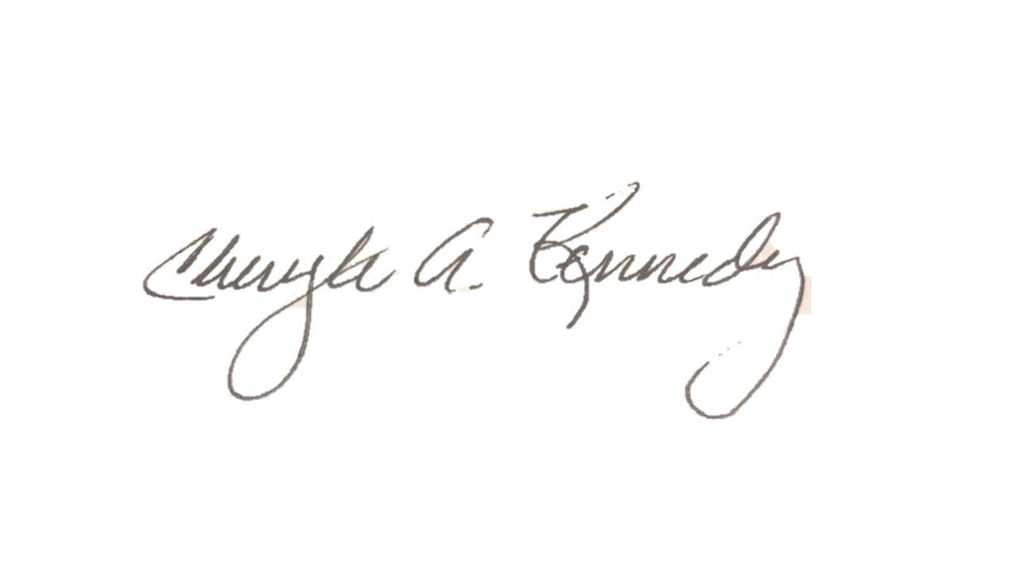

Chairman
July 16, 2019 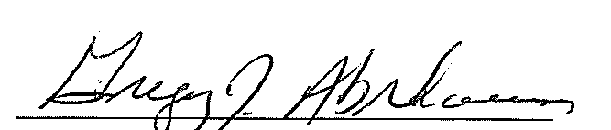
DATE Secretary

