RESOLUTION # 19-04-15
Northwest Traditional Foods Policy Project

WHEREAS, the Northwest Portland Area Indian Health Board (hereinafter “NPAIHB” or the “Board”) was established in 1972 to assist Tribal governments to improve the health status and quality of life of Indian people; and

WHEREAS, the NPAIHB is a non-governmental “tribal organization” as defined by the Indian Self-Determination and Education Assistance Act (P.L. 93-638 seq. et al) that represents forty-three federally recognized tribes in the states of Idaho, Oregon, and Washington; and

WHEREAS, in accordance with the definitions of the Indian Self-Determination and Education Assistance Act at 25 USCS § 450b, a tribal organization is recognized as a governing body of any Indian tribe and includes any legally established organization of Indians which is controlled, sanctioned, or chartered by such governing body or which is democratically elected by the adult members of the Indian community to be served by such organization and which includes the maximum participation of Indians in all phases of its activities; and

WHEREAS, the NPAIHB is dedicated to assisting and promoting the health needs and concerns of Indian people; and

WHEREAS, diabetes is the fourth leading cause of death among Washington AI/ANs, and the fifth leading cause of death among AI/ANs in Oregon and Idaho; and

WHEREAS, heart disease is the leading cause of death among AI/ANs in Idaho and Washington, and the second leading cause after cancer for Oregon AI/ANs; and

WHEREAS, stroke is the seventh leading cause of death among Oregon AI/ANs, and the eighth leading cause of death among AI/ANs in Washington and Idaho; and

WHEREAS, the NPAIHB’s Northwest Tribal Epidemiology Center (NW Tribal EpiCenter) has worked with tribes and tribal clinics throughout the Northwest for over 5 years on upstream approaches to chronic disease prevention in the areas of nutrition and traditional foods, and is authorized to carry out the goals and objectives of the Robert Wood Johnson (RWJ) Foundation: Healthy Eating Research Addressing: Nutritional Disparities, Improving Nutrition, and Increasing Food Security – Integral Components to Building A Culture of Health in America – Round 12; and

WHEREAS, the proposed Community Based Participatory Research Funding would be a 2-year research project addressing priorities identified by NPAIHB member tribes including chronic disease prevention, obesity, diabetes and the need to create public health strategies that integrate and reflect tribal culture and values; and

WHEREAS, the project would examine the implementation of a traditional foods educational curriculum within a tribe’s early childhood care and education setting including partnering on nutrition policy development and training for childcare center caregivers; and

WHEREAS, the results will be disseminated with all Northwest Tribes to strengthen the regional approaches to improve tribal youth’s ability to learn about and access to healthy, traditional foods; and

WHEREAS, this specific funding opportunity supports developing the capacity of states, territorial, and local education agencies to deliver sustainable, culturally relevant initiatives for AI/AN children ages 0-8 and their families; and

WHEREAS, the goals of this initiative are consistent with the goals and objectives of both the NPAIHB and the NW Tribal EpiCenter.

THEREFORE, BE IT RESOLVED that the NPAIHB endorses and supports efforts by staff of the NW Tribal EpiCenter, under the guidance of the Executive Director, to pursue funding through the Robert Wood Johnson (RWJ) Foundation: Healthy Eating Research Addressing: Nutritional Disparities, Improving Nutrition, and Increasing Food Security – Integral Components to Building a Culture of Health in America – Round 12 funding opportunity.

CERTIFICATION

RESOLUTION # 19-04-15
The foregoing resolution was duly adopted at the regular session of the Northwest Portland Area Indian Health Board. A quorum being established; 23 for, 0 against, 0 abstain on July 16 , 2019.
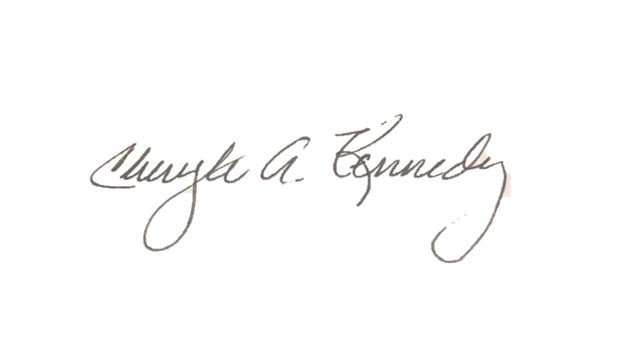

Chairman
July 16, 2019 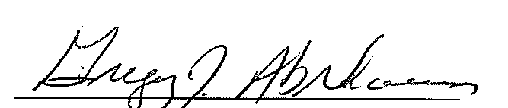
DATE Secretary

