Resolution # 19-04-16

Public Health Improvement and Training
Tribal Public Health Capacity Building and Quality Improvement Umbrella Cooperative Agreement – 2019 Supplements

WHEREAS, the Northwest Portland Area Indian Health Board (hereinafter “NPAIHB” or the “Board”) was established in 1972 to assist Tribal governments to improve the health status and quality of life of Indian people; and

WHEREAS, the Northwest Portland Area Indian Health Board is a “tribal organization” as defined by the Indian Self-Determination and Education Assistance Act (P.L. 93-638 seq. et al) that represents forty-three federally recognized tribes in the states of Idaho, Oregon, and Washington; and

WHEREAS, in accordance with the definitions of the Indian Self-Determination and Education Assistance Act at 25 USCS § 450b, a tribal organization is recognized as a governing body of any Indian tribe and includes any legally established organization of Indians which is controlled, sanctioned, or chartered by such governing body or which is democratically elected by the adult members of the Indian community to be served by such organization and which includes the maximum participation of Indians in all phases of its activities; and

WHEREAS, the Northwest Portland Area Indian Health Board is dedicated to assisting and promoting the health needs and concerns of Indian people; and

WHEREAS, the primary goal of the NPAIHB is to improve the health and quality of life of its member Tribes; and

WHEREAS, in furtherance of this goal in 1997, NPAIHB established the Northwest Tribal Epidemiology Center (EpiCenter) in an effort to improve the quality of American Indian and Alaska Native {Al/AN) epidemiology data; and

WHEREAS, The Epicenter has gained national recognition for developing and implementing many useful and innovative projects to improve the health and quality of life of Northwest tribes and has served as a national model for other Indian Health Service {IHS) areas to emulate in establishing their EpiCenter programs; and

WHEREAS, the NPAIHB endorsed, by Resolution #18-03-03, ratified by a quorum of the full Board of Delegates on April 19, 2018, the submission of a proposal to the Centers for Disease Control and Prevention (CDC) for funding opportunity
CDC-RFA-OT18-1803 "Tribal Public Health Capacity Building and Quality Improvement Umbrella Cooperative Agreement," and was awarded funds for a five-year period, 2018-2023, to strengthen and improve optimize the quality and performance of the tribal public health system, including infrastructure, workforce, data and information systems, programs and services, resources and communication, and partnerships; and

WHEREAS, the CDC released a supplemental funding opportunity open only to current grantees under the above-mentioned cooperative agreement; and
WHEREAS, the following CDC-proposed supplemental project plans include those focused on the following key program areas:
- Addressing Barriers to Childhood Immunizations through Communication and Education;
- Building Capacity of Tribes to Support Smoking Cessation;
- Increasing Tribal Epidemiology Center Capacity to Support Tribes in Achieving Public Health Accreditation Standards;
- Inspiring Students to Consider Tribal Public Health as a Career Choice;
- Investigate and Raise Awareness of Relationships between the Environment and Disease Relevant to Tribal Populations; and

WHEREAS, these supplemental proposals will provide additional opportunities to optimize the quality and performance of the tribal public health system to address the key areas above; and

WHEREAS, Northwest Tribes have expressed explicit interest in each of these project areas; and

WHEREAS, the goals of the proposed supplemental project plans are consistent with the goals and objectives of NPAIHB; and

THEREFORE BE IT RESOLVED, that the NPAIHB endorses and supports an effort by staff of the NPAIHB, under the guidance of the Executive Director, to submit supplemental workplan applications to the CDC for funding opportunity CDC-RFA-OT18-18030201SUPP19 "Tribal Public Health Capacity Building and Quality Improvement Umbrella Cooperative Agreement Supplement."

CERTIFICATION

Resolution # 19-04-16

The foregoing resolution was duly adopted at the regular session of the Northwest Portland Area Indian Health Board. A quorum being established; 23 for, 0 against, abstain on July 16 , 2019.

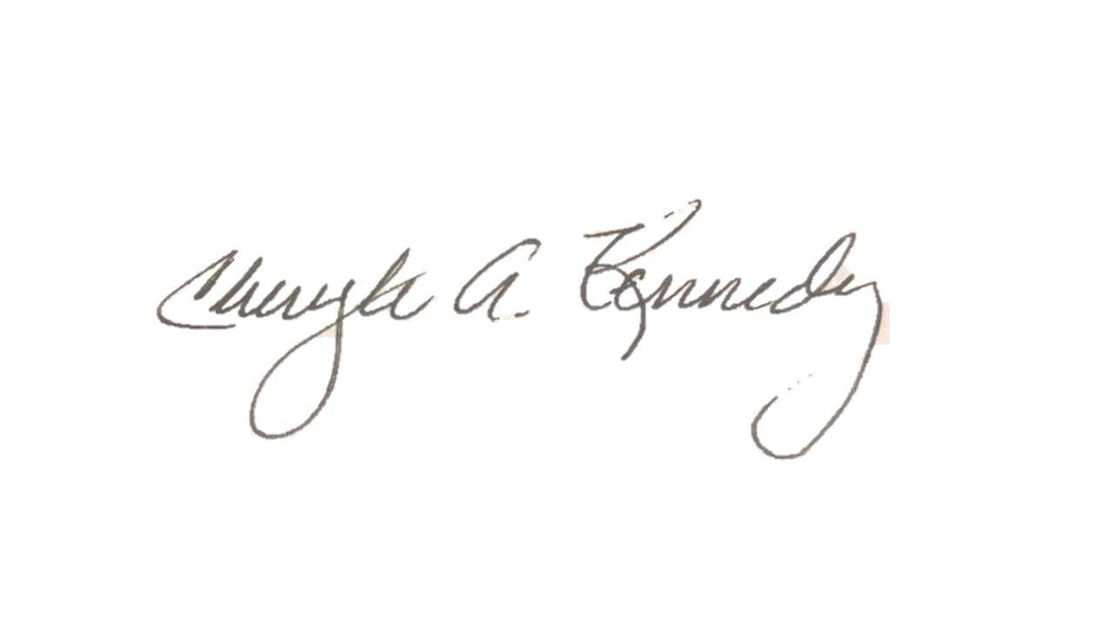

Chairman
July 16, 2019 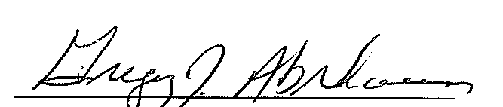
DATE Secretary

