NORTHWEST
PORTLAND
AREA
INDIAN
HEALTH
BOARD

Burns-Paiute Tribe
Chehalis Tribe
Coeur d’Alene Tribe
Colville Tribe
Coos, Siuslaw, &
Lower Umpqua Tribe
Coquille Tribe
Cow Creek Tribe
Cowlitz Tribe
Grand Ronde Tribe
Hoh Tribe
Jamestown S’Klallam Tribe
Kalispell Tribe
Klamath Tribe
Kootenai Tribe
Lower Elwha Tribe
Lummi Tribe
Makah Tribe
Muckleshoot Tribe
Nez Perce Tribe
Nisqually Tribe
Nooksack Tribe
NW Band of Shoshoni Tribe
Port Gamble S’Klallam Tribe
Puyallup Tribe
Quileute Tribe
Quinault Tribe
Samish Indian Nation
Sauk-Suiattle Tribe
Shoalwater Bay Tribe
Shoshone-Bannock Tribe
Siletz Tribe
Skokomish Tribe
Snoqualmie Tribe
Spokane Tribe
Squaxin Island Tribe
Stillaguamish Tribe
Suquamish Tribe
Swinomish Tribe
Tulalip Tribe
Umatilla Tribe
Upper Skagit Tribe
Warm Springs Tribe
Yakama Nation

2121 S.W. Broadway
Suite 300
Portland, OR 97201
Phone: (503) 228-4185
Fax: (503) 228-8182
www.npaihb.org
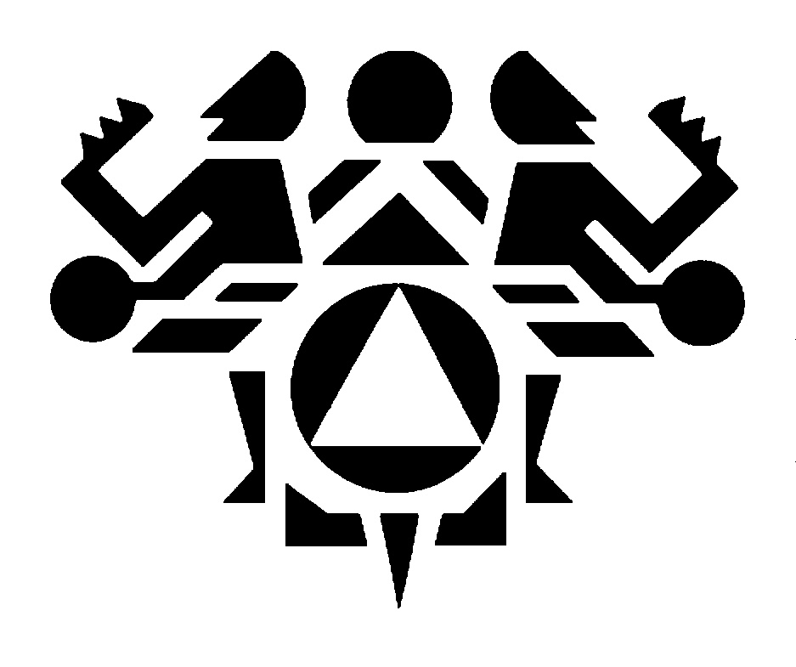
June 5, 2020

Re: In Solidarity with Black Lives Matter

The Northwest Portland Area Indian Health Board (NPAIHB) stands with our Black relatives, many of whom are also Native. We know well the pain and agony of the current and historical systemic racism on Black people, Native people, and people of color. We grieve with you for George Floyd and the countless loved ones who are victims of racism and police brutality.

We send our deepest pride to each and every person who is part of the Black Lives Matter (BLM) movement to create change. Despite the risks in this pandemic, so many have been out on the streets to bring the roar of justice to all our ears because complacency is a matter of life or death. Racial disparities, white supremacy, violence against indigenous people impact us all in the same ways. This movement has once again grown into a strong and hopeful movement in the fight against oppression.

We are unified with you and demand nationwide systematic change. Addressing the injustices and disparities, bringing fairness to the criminal justice system and reparations will go a long way to healing. We honor and respect the work of BLM and everyone who is fighting for change. We offer you our love, support and prayers in this movement.

In Solidarity,

NPAIHB Delegates

The Northwest Portland Area Indian Health Board (NPAIHB) is a tribal organization, established in 1972, under the Indian Self-Determination and Education Assistance Act (ISDEAA), P.L. 93-638 that advocates on behalf of the 43 federally-recognized Indian Tribes in Idaho, Oregon, and Washington on specific health care issues. The Board’s mission is to eliminate health disparities and improve the quality of life of American Indians and Alaska Natives (AI/AN) by supporting Northwest Tribes in the delivery of culturally appropriate, high quality health care.

