RESOLUTION # 19-04-01

Oregon Health Authority and Oregon Health Sciences University --Healthy Oregon Workforce Training Opportunity (HOWTO) Grant

WHEREAS, the Northwest Portland Area Indian Health Board (hereinafter “NPAIHB” or the “Board”) was established in 1972 to assist Tribal governments to improve the health status and quality of life of Indian people; and

WHEREAS, the NPAIHB is a non-governmental “tribal organization” as defined by the Indian Self-Determination and Education Assistance Act (P.L. 93-638 seq. et al) (ISDEAA) that represents forty-three federally recognized tribes in the states of Idaho, Oregon, and Washington; and

WHEREAS, in accordance with the definitions of the ISDEAA at 25 USCS § 450b, a tribal organization is recognized as a governing body of any Indian tribe and includes any legally established organization of Indians which is controlled, sanctioned, or chartered by such governing body or which is democratically elected by the adult members of the Indian community to be served by such organization and which includes the maximum participation of Indians in all phases of its activities; and

WHEREAS, the NPAIHB is dedicated to assisting and promoting the health needs and concerns of Indian people; and

WHEREAS, American Indians and Alaska Natives (AI/AN) have very limited access to health care services and are disproportionately affected by behavioral health disparities and these disparities are directly attributed to the lack of health professionals in AI/AN communities, which has caused a serious access issue and backlog of health services for AI/AN people; and

WHEREAS, many of our Oregon Tribes have great difficulty and face significant challenges in recruiting health professionals to serve their communities that results in further challenges in ensuring continuity and comprehensive healthcare for AI/AN people; and

WHEREAS, this specific funding opportunity supports developing the behavioral health workforce for AI/AN people in Oregon to deliver sustainable, culturally relevant behavioral health services in AI/AN communities; and

WHEREAS, the Alaska Community Health Aide Program (CHAP) has been in existence since 1964 as a program of the Indian Health Service (IHS) and includes Community Health Aides, Behavioral Health Aides (BHA) and Dental Health Aide Therapists; and

WHEREAS, CHAP grows providers from within tribal communities who provide patient-centered quality care that comes from providers that understand the history, culture, and language of their patients, and

WHEREAS, CHAP workforce is contingent upon the development of CHAP education programs and training centers; and

WHEREAS, NPAIHB has a longstanding relationship with Northwest Indian College, Northwest Native American Center of Excellence, and Alaska Native Tribal Health Consortium to expand CHAP for Northwest Tribes;

WHEREAS, AI/ANs in Oregon are faced with significant behavioral health issues, including:
- Higher rates of poor mental health and depression than non-Hispanic white (NHW) in the state; and
- Despite reporting relatively high levels of poor mental health, AI/AN men were less likely than NHW men to receive treatment for these conditions; and
- Females were more likely than males to be hospitalized for suicide, while males had higher mortality rates from suicide; and
- Suicide is the eighth leading cause of death for AI/AN in Oregon; and

WHEREAS, Oregon Tribes and AI/ANs would benefit from a BHA training center in Oregon; and

WHEREAS, one goal in NPAIHB’s strategic plan states that NPAIHB will be a national leader in healthcare delivery, and will support health infrastructure development for our member tribes; and another goal is that NPAIHB will support health promotion and disease prevention activities occurring among Northwest Tribes; and

WHEREAS, Oregon Health Authority (OHA) and Oregon Health Sciences University (OHSU) – Healthy Oregon Workforce Training Opportunity (HOWTO) have announced a funding opportunity that would support an Oregon CHAP BHA training center; and

WHEREAS, a successful proposal for this funding initiative to OHA and OHSU would provide an opportunity for Oregon Tribes to expand their behavioral health workforce by growing their own providers and increasing behavioral health services to AI/AN in Oregon.

THEREFORE, BE IT RESOLVED that the Northwest Portland Area Indian Health Board endorses and supports efforts by staff of the Tribal Community Health Provider Project, under the guidance of the Executive Director, to pursue funding through the Oregon Health Authority and Oregon Health Sciences University – Healthy Oregon Workforce Training Opportunity (HOWTO) funding to support an Oregon CHAP BHA training center.

CERTIFICATION
NO: 19-04-01

The foregoing resolution was duly adopted at the regular session of the Northwest Portland Area Indian Health Board. A quorum being established; for, against, abstain on , 2019.
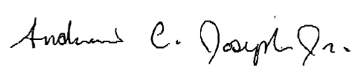

Chairman
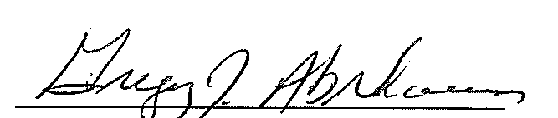
Secretary

